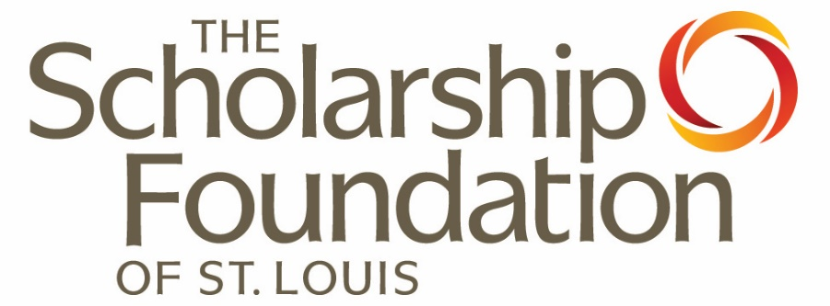

Financial Aid
Basics

We invite you to share these materials with students and families. Please attribute these materials to The Scholarship Foundation of St. Louis and link back to the original source on the Foundation’s website to ensure students and families have the most accurate, up-to-date information.

Policy is often changing and that is true for financial aid policy and programs. The Scholarship Foundation updates all materials, as needed, throughout the year and all content in this workbook is accurate as of the date on the back of page; please check the Foundation’s website at www.sfstl.org for an updated version or contact us to speak with a member of our advising team to understand any changes that have been made after that date.

Table of Contents

Objectives 2
Objective 1: Get Ready 3
Objective 2: Build Support System 4
Objective 3: Understand Financial Resources 5-9
Objective 4: Determining Financial Need 10
How do I fill the gap? 11
Get Organized 12
Objective 5: Scholarship Searches 13
Helpful Hints 14
Objective 6: Scholarship Foundation Loans 15
Web Resources 16-17
FSA IDs 18-19

Objectives

- Assess where you are in the planning process and create a strategy.

- Identify the human resources in your life—and know how to utilize them to build a support system!

- Learn about the different federal, state, and school-based financial resources available to you.

- Learn the process of determining financial need

- Identify scholarship resources and understand how to implement a successful scholarship search.

- Determine eligibility for The Scholarship Foundation’s interest-free, fee-free loans.

Objective 1: Get Ready
Know where you are and create a plan of action.

- Determine where YOU are in the college planning process. Remember, all students must take similar steps, but there is uniqueness to your individual path.

- Define how much time you realistically have to get started and set a comfortable and realistic pace. Consider college admissions deadlines, priority scholarship deadlines, and financial aid matters. Do not wait until the last minute to either do your research or apply.

- Reduce anxiety and identify areas where you may need more assistance or guidance. This is a stressful process; be proactive and make a calendar of your tasks and deadlines. Use your resources.

- Outline a strategic approach or a plan of action; know the concrete steps necessary to reach your goal. Having a strategy prevents confusion, makes the process easier, and will (hopefully) ensure you do not miss deadlines!

- Find a starting point. You must start somewhere. Getting started will help make this easier!

- Create back-up plans; things don’t always work out. Having a back-up plan (or two, or three!) in place early is smart! Always apply to a range of schools, plan to compare financial aid offers, and have back-up plans in case your first choice doesn’t work out.

Objective 2: Build your support system.
Identify people to help and support you!
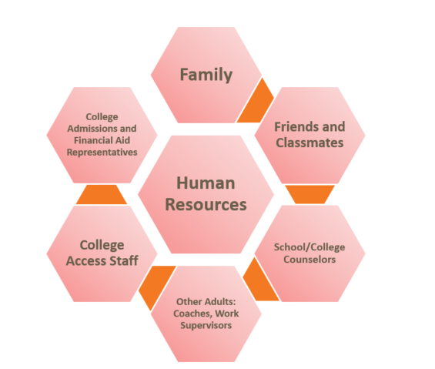

These people can be your human resources! Reach out for their support—they can help you navigate the path, answer questions, provide recommendations/letters of reference, listen to your concerns, and assist you with staying on track. Communicate with them!

Build a support network!

Objective 3: Understand Financial Resources!

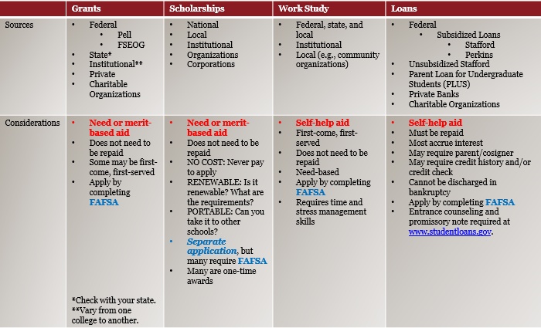

Objective 3: Understand Financial Resources!

What is the FAFSA?

The FAFSA is the Free Application for Federal Student Aid!

- It is free—always complete at https://studentaid.gov!
- Students must complete to be considered for all federal aid, most state aid, and many school-based awards.
- The 2026-27 FAFSA is expected to open on October 1, 2025.
- Students must create a Federal Student Aid (FSA) ID. The FSA ID consists of a Username and Password, which will be used to log into the FAFSA. FSA IDs are created at: https://studentaid.gov/fsa-id/create-account. (See pages 17-18 for more info!)
- Students and their identified contributor(s), which may be their parent(s) or spouse, will need to provide consent for the IRS to share their Financial Tax Information (FTI). Consent must be provided, regardless of tax filing status. Although the FAFSA can still be submitted without consent, the form will not be processed and will be considered incomplete until consent is provided. The FAFSA for 2026-27 will use 2024 tax information.
- The FAFSA calculates the Student Aid Index, or SAI. The SAI determines a student’s eligibility for certain types of federal student aid. It will be subtracted from the cost of attendance to determine their financial need.
- There is lots of free help and support for completing your FAFSA!
  - Live help online at https://studentaid.gov/help-center or call 1.800.433.3243.
  - The Scholarship Foundation can help you complete the FAFSA! Call 314.725.7990 or email info@sfstl.org to make an appointment.

Objective 3: Understand Financial Resources!
Federal Grants | State Grants
Pell Grant  - Federal grant  - Current maximum award: $7,395  - Current minimum award: $740  - Need-based aid  - FAFSA required  - May receive for up to12 semesters or the equivalent.  - Maximum and minimum Pell awards can be determined using federal poverty guidelines.  - Pell awards can also be calculated by the SAI; maximum Pell-SAI equals Pell award. | Access Missouri  - State grant; attend Missouri school  - Current award amounts vary annually due to state appropriations; minimum award is $1,750.  - Award amounts may be tiered based upon SAI.  - Need-based aid  - FAFSA Required  - SAI Cutoff: $12,000  - Priority deadline is February 1st; applications on file by April 1st may receive funds depending on availability.
Federal Supplemental Educational Opportunity Grant (FSEOG)  - Federal grant  - Current maximum award: $4,000  - Need-based aid  - FAFSA required  - First-come, first-served  - Students with lowest SAIs, Pell eligibility are given priority in the award process. | A+  - State grant  - Students at approved high schools who have completed necessary requirements.  - FAFSA required  - Covers tuition and fees at any Missouri community college (after Pell eligibility applied).  - Funding limited to 6 semesters.  - Must be used within 4 years of graduation from high school.
IL Monetary Award Program (MAP Grant)
- State grant; IL residents attending IL college
- Award amounts vary, but the current maximum is $4,720
- Need-based aid
- FAFSA Required
- Awarded on a first-come, first-served basis. File FAFSA at the earliest convenience.

Work-Study
- Provides part-time jobs for undergraduate and graduate students with financial need.
- FAFSA required
- Paid by the hour.
- Wages must equal at least current federal minimum wage.
- Amount earned cannot exceed Federal Work Study (FWS) award.
- Award amount, class schedule, and academic progress are considered when assigning work hours for work study.

Student Loans
Good or Better Loans | “Be Cautious”: Limit or Avoid Loans
Subsidized Stafford  - Federal loan  - Students with financial need  - Government pays interest while in school  - FAFSA required  - The interest rate on subsidized loans first disbursed to undergraduate students between July 1, 2025, and June 30, 2026, will be fixed at 6.39%.  - Students have 6-month grace period. | Unsubsidized Stafford  - Federal loan  - NOT need-based.  - Government does NOT pay interest, which means interest accrues immediately.  - FAFSA required  - The interest rate on unsubsidized loans first disbursed to undergraduate students between July 1, 2025, and June 30, 2026, will be fixed at 6.39%.  - Students have 6-month grace period.
Scholarship Foundation  Interest-Free Loan  - Private loan  - Students with financial need  - Maximum award is $11,000 per year  - 2- and 4-year schools around the country; must be accredited and nonprofit  - Academic: minimum 2.0 cumulative GPA  - Character: Demonstrate honesty, good judgment, forthrightness  - Financial need  - FAFSA or Need Analysis Form required  - Students have 12-month grace period. | PLUS Loan  - Student must be dependent  - Biological or adoptive parent borrows for the student’s education.  - Credit-based  - Effective July 1, 2026, Parent PLUS loans have a limit of $20,000 per year for each dependent student, and a lifetime limit of $65,000. There is an aggregate limit of $275,000  - The interest rate on PLUS loans first disbursed between July 1, 2025, and June 30, 2026, will be fixed at 8.94%.  - Repayment begins when loan is fully disbursed. First payment is 60 days after final disbursement.  - FAFSA required
Private Loan
- Institutional
- Bank
- May have credit requirements
- May require cosigner
- High and/or variable interest rate
- Limited, if any, options for deferment or forbearance
- FAFSA required: all private bank loans must be certified by financial aid administrator.
Objective 4: Determining Financial Need

Cost of Attendance (COA)
(Cost of Attendance is the total cost of attending a particular college for one year. COA includes direct costs (paid directly to school) such as tuition, fees, housing and food, as well as indirect costs (expected expenses not paid to school) including transportation, off campus living expenses, personal expenses, and books and supplies.)
-Student Aid Index (SAI)
(The Student Aid Index, or SAI, is the output of a processed FAFSA and determines each student’s eligibility for certain types of federal student aid, as well as some state aid and, perhaps, institutional aid.)
-Other Financial Assistance (OFI)
(Other Financial Assistance is grant, scholarship, or loan aid that is not Title IV, or Federal Student Aid, found in the Higher Education Act.)

= Amount of Need
Gift Aid
(Gift Aid is “free” money that typically does not need to be repaid and may include federal and state need-based grants, as well as institutional grants or scholarships the student is eligible to receive based on either financial need or merit.)
=Unmet Need
Unmet need may be covered all, or in part, by Federal student loans in the student and/or parent(s) name(s).

How do I fill the gap?

Undergraduate students may be eligible for Stafford Loans, which may be a mix of subsidized and unsubsidized loans. The following chart outlines how much in total a student is eligible for by grade level and the maximum of that amount that may be subsidized. The remaining amount offered to a student would be unsubsidized.

Grade Level  Determined by credit hours earned. | Maximum Stafford Loan Eligibility-Dependent Student | Maximum Stafford Loan Eligibility-Independent Student | Maximum Subsidized Stafford Loan Eligibility
First-Year College Student | $5,500 | $9,500 | $3,500
Sophomore | $6,500 | $10,500 | $4,500
Junior | $7,500 | $12,500 | $5,500
Senior | $7,500 | $12,500 | $5,500

As an undergraduate, students may borrow a total amount of loans in aggregate:

Dependent Students
May borrow a total of $31,000 in Stafford loans, of which a maximum of $23,000 may be subsidized.
Independent Students
May borrow a total of $57,500 in Stafford loans, of which a maximum of $23,000 may be subsidized.

A dependent student is required to provide parent information on the FAFSA, while an independent student is not.

Independent students are
- 24 years of age,
- married,
- working on a graduate degree, after completing a bachelor’s degree,
- providing more than 50% of the financial support for a child of their own or another dependent,
- a veteran or on active duty,
- in court-ordered legal guardianship,
- an emancipated minor,
- in foster care or a ward of the court or state, or
- homeless or unaccompanied and at risk of being homeless
Get organized!
- Keep everything together! This includes:
  - College Applications
  - Financial aid forms
  - Student and parent taxes (NOTE: IRS Tax Transcript)
  - Students must create a Federal Student Aid (FSA) ID. The FSA ID consists of a Username and Password, which will be used to log into the FAFSA.
FSA IDs are created at: https://studentaid.gov.
  - FAFSA Submission Confirmation (NOTE: Can be found in student’s email.)
  - FAFSA Submission Summary (NOTE: Accessed by the student at https://studentaid.gov)
  - ALL communication from schools where student applies
- Try an accordion file folder.
  - Keep each school separate.
  - Keep copies of ALL paperwork:
    - Applications
    - Verification forms
    - Deposits/agreements, etc.
- Keep a calendar with all important deadlines. You don’t want to miss any of the following:
  - Admissions deadlines
  - Scholarship deadlines
  - Priority deadlines for the FAFSA
  - Financial aid appeal deadlines
  - Payment plan deadlines

Objective 5: Implementing a Successful Scholarship Search

Start with your college or university first! Make sure you check with schools regarding their scholarship process:
- Are you considered for scholarships when you apply for admissions? What is the deadline?
- Is there a separate scholarship application? What is the deadline?
- Some schools offer scholarships both ways—do your research!

Research local opportunities first!
- Visit myscholarshipcentral.org to search for St. Louis-area and Missouri opportunities:
  - Scholarship Central is a common application, which allows you to apply for multiple opportunities in one place!
  - External Opportunities are scholarships linked through the website and include all pertinent information, although they cannot be applied to via Scholarship Central.
- Check with your school counselor for opportunities through your school and community. If you haven’t already:
  - Make an appointment with your school or college counselor.
  - Check your school counselor’s website for any posted opportunities.
  - Visit the school counselor’s offices; they likely have a bulletin board or scholarship area. Check it out!

There are national opportunities too!
- First, never, ever pay for a scholarship search!
- Consider these two things:
  - Is it renewable?
  - Is it portable? (i.e., Can you take it from one school to another if you transfer?)
- Visit fastweb.com, scholarships.com, or bigfuture.collegeboard.org/‌scholarship-search to start searching today!

Helpful Hints: Tips on applying to college and navigating the financial aid process!

Apply early! It is a great idea to submit applications early! Many priority deadlines are in November and early December. This helps to reduce stress and it may also place you in line early for financial aid. It also allows for additional time in the decision-making process.

Apply to more than one school! Give yourself options! Apply to a variety of schools. (HINT: This can even be helpful when appealing for additional financial aid from a school.)

Cost ≠ Affordability. Cost and affordability do not always mean the same thing; looking only at the sticker price (cost) of a college does not tell you everything you may need to know about affordability. Until you apply and receive financial aid packages you will not know which school will really be the most affordable. Note: Some selective schools may require the CSS Profile, which is another financial aid application. Apply online at https://cssprofile.collegeboard.org/.

If necessary, appeal early! Investigate the financial aid appeals process or a professional judgment review at your possible school(s)! It is possible to appeal a financial aid package. It is important to contact your school ASAP if you are worried about getting your parents’ information for the FAFSA or think you have a unique situation.

Know your personal loan/debt limit! Do research on loan terms, interest rates, annual and aggregate loan amounts so that you ensure you are borrowing the loans with the best possible terms. In addition, consider your area of study and school choice—what is your income potential when you graduate and what will are your student loan monthly payments.

Objective 6: Scholarship Foundation Eligibility
Requirements—Grants and Interest-Free Loans

Students demonstrating financial need, academic promise (a 2.0 cumulative G.P.A. on a 4.0 scale), and strong character are eligible for consideration for grant and loan programs.

Students must be permanent residents of the program’s eligible service area (more than 2 years) or graduate from a St. Louis area high school.

Students can attend any school in the country, as long as it is accredited and nonprofit. Scholarship Foundation does not fund for-profit schools, which are institutions operated by private, profit-seeking businesses. Additionally, some scholarship programs may have additional criteria for eligible schools.

The Scholarship Foundation’s deadline is April 15th and students are considered for full-academic year funding.

All funds are renewable, provided that students continue to meet requirements.

Students may receive a conditional denial for too much need. This letter is sent to applicants for whom there are concerns about significant debt. When reviewing applications and making awards, The Scholarship Foundation expects a student will borrow no more than $11,000 per year and that this debt will be covered entirely by a grant and/or interest-free, fee-free loan from The Scholarship Foundation. Students who receive this letter can appeal if they are able to secure additional grant or scholarship aid; have other resources available to help reduce costs; or are willing to consider a school that is more affordable to minimize debt burden.

Web Resources
Need help choosing a school that is the right fit for you? Check out these websites:
www.collegeresults.org
www.campustours.com
https://bigfuture.collegeboard.org/
http://youcango.collegeboard.org/
www.workcolleges.org

Do you have questions about the ACT or SAT? Try here to learn more:
www.actstudent.org
http://sat.collegeboard.com/home

Confused? Looking for more information? Here are some resources to help you navigate the pathway to college!
www.dhe.mo.gov
www.isac.org
www.mappingyourfuture.org
www.knowhow2go.org
www.collegeboard.com
http://going2college.org
www.collegedata.com
Web Resources
Applying for or seeking to understand financial aid from the Federal government? Make sure you check out these websites:
https://studentaid.gov/aid-estimator/
https://studentaid.gov/h/apply-for-aid/fafsa
http://studentaid.ed.gov
www.collegefinancecenter.org

Looking for scholarship opportunities? Check out these scholarship resources:
https://opportunity.collegeboard.org/
www.chegg.com
www.hsf.net
www.uncf.org

Do you have questions about Scholarship Foundation’s programs? For more information visit: sfstl.org

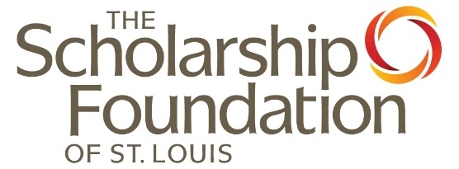
Federal Student Aid (FSA) ID

Federal Student Aid IDs (FSA ID), or StudentAid.gov accounts, are a username and password, created by the individual student and/or parent. FSA IDs are used to log-in to the Student Aid website, provide consent and approval for the IRS to share tax information, and sign the Free Application for Federal Student Aid (FAFSA). All FAFSA-filers are required to create an FSA ID; if the student is dependent, a parent and, in some cases, two parents are required to create an FSA ID. To determine your dependency status, please visit: https://studentaid.gov/apply-for-aid/fafsa/filling-out/dependency.

- Create an FSA ID at https://studentaid.gov.
- Many FSA IDs are linked to the user’s Social Security Number. Please double check that the name, birthdate, and SSN used on the FSA ID application match exactly what is listed on your Social Security card. They will not work if the Social Security Administration cannot verify the individual’s identity. Identity verification occurs immediately; if your identity cannot be verified, you will be prompted to correct information and will be unable to begin the FAFSA until your identity is verified.
- Parent(s) or spouse contributors to a student’s FAFSA, who do not have a Social Security Number, are still able to create an FSA ID. Individuals will create an ID through the same process but will have their identity verified through a set of knowledge-based identity verification questions.
Please contact us with your questions, concerns, or for help with the process!
- Users are required to link an email address to their FSA ID and may choose to link a cell phone number, which is recommended. Both the email address and a cell phone number must be verified through a two-factor authentication code. The FSA ID is not finalized until the email address, and the cell number, if entered, are verified. Remember:
  - A verified email address can be used interchangeably with the username, offering greater flexibility.
  - A cell phone number can be used across multiple accounts (up to five) for multifactor authentication. If the username and/or password are forgotten, a user may send a secure code to their verified email and/or cell phone number, which allows for easier retrieval and/or reset.
- Federal Student Aid uses a two-step verification process. All FSA ID users are required to set up, and use, two-step verification. Individuals may use their verified email address and/or cell phone numbers for two-step verification; users also may choose to use an authenticator app.
- All FSA ID users will receive an optional backup code. It provides an additional account verification option, although it is a one-time use only. Consider copying the backup code and storing it in a safe and secure place.
- Federal Student Aid does not permit passwords to include any aspects of the user’s legal name, DOB, or SSN.
- Document your information in a safe and secure way; best practice is to store in a password manager. You can also document photos in a locked note or album on a device. If you write it down, be sure to save it in a secure file at home.

Although there are many reasons why students create parent FSA IDs (and vice versa), please only create an FSA ID for yourself. An FSA ID serves as a legally binding signature. When it is necessary, one suggestion is to use the same password for both accounts, to minimize what detail needs to be remembered.

Student:
Email Address:
Cell Phone Number: _____________________________________________________________
Username:
Password:
Backup Code: _______________________________________________________

Parent 1 (If applicable):
Email Address:
Cell Phone Number: _____________________________________________________________
Username:
Password:
Backup Code: _______________________________________________________

Parent 2 (If applicable):
Email Address:
Cell Phone Number: _____________________________________________________________
Username:
Password:
Backup Code: _______________________________________________________

The Scholarship Foundation’s Student Advising Team

Liliana De La Garza Fischer Ricky Hughes
Bilingual Student Advisor Student Advisor
(314) 932-6935 (314) 932-6939
liliana@sfstl.org ricky@sfstl.org

DeVonte’ (DJ) Jackson Dominesha Newton
Student Advisor Lead Student Advisor
(314) 932-6940 (314) 932-6937
dj@sfstl.org dominesha@sfstl.org

Teresa Stock Steinkamp, LMSW
Director of Advising
(314) 932-6932
teresa@sfstl.org

Learn more and meet the advisors:
https://sfstl.org/for-students/student-advising/

The Scholarship Foundation of St. Louis
6825 Clayton Ave, Suite 100, St. Louis, MO 63139
main: 314.725.7990
fax: 314.725.5231
sfstl.org

Teresa Stock Steinkamp, LMSW
Revised May 2026

$0-$7K SAIs receive state appropriated maximum. SAIs $9,001-$12K state appropriated minimum. SAIs between $7,001-$9K may vary. This award structure has been in place since Access Missouri’s beginning, but funds are not always sufficient to tier award amounts between the maximum and minimum.
Interest on this loan is recalculated and adjusted each year on July 1st; the interest rate is not to exceed 8.25%. Rate is set based on 10-year Treasury note +2.05% for this loan.
Interest on this loan is recalculated and adjusted each year on July 1st; the interest rate is not to exceed 8.25%. Rate is set based on 10-year Treasury note +2.05% for this loan.
Interest on this loan is recalculated and adjusted each year on July 1st; the interest rate is not to exceed 10.5%. Rate is set based on 10-year Treasury note +4.60% for this loan.
To read more about subsidized and unsubsidized loans, please visit: https://studentaid.gov/understand-aid/types/loans/subsidized-unsubsidized.
Dependent students, whose parent goes through the credit check for the Parent Loan for Undergraduate Students and are denied, are eligible for the independent student borrowing limits.
Once a student borrows a loan, the interest rate is fixed for the life of the loan. However, each year a student is offered a new loan, with a new interest rate. Interest rates are adjusted annually, beginning on July 1, and oftentimes announced in May. See footnotes on page 7 for more detail.
For verification purposes, schools may request an IRS Tax Transcript. You can secure a copy from the IRS if you are selected for verification. Call 1.800.908.9946 or visit www.irs.gov. If you do not file or will not file, you may need a non-tax filer form, which can also be secured from the IRS.
You may always file a FAFSA but be aware that most colleges and states (including Missouri!) have priority deadlines for FAFSA if you want to be considered for aid. Check with individual schools!
You have the right to appeal your financial aid from a school—either for financial or competitive reasons!
Many grant programs awarded by the Foundation have specific geographic areas eligible to apply. The Foundation’s interest-free loan program and many scholarships use the St. Louis Metropolitan Statistical Area (MO and IL). However, several grant programs extend to other parts of the state of Missouri. Students applying for any program should carefully read eligibility criteria. For more information: https://sfstl.org/financial-aid/student-loans-and-grants/.

