

FAFSA:
Free Application for Federal Student Aid

We invite you to share these materials with students and families. Please attribute these materials to The Scholarship Foundation of St. Louis and link back to the original source on the Foundation’s website to ensure students and families have the most accurate, up-to-date information.

Policy is often changing and that is true for financial aid policy and programs. The Scholarship Foundation updates all materials, as needed, throughout the year and all content in this workbook is accurate as of the date on the back of page; please check the Foundation’s website at www.sfstl.org for an updated version or contact us to speak with a member of our advising team to understand any changes that have been made after that date.

Table of Contents

Objectives pg. 3

Objective #1: Understand Acronyms and Jargon pg. 4

Objective #2: What, Why, When, and How of FAFSA pg. 5

Objective #3: Identify the Correct FAFSA Website pg. 6

Objective #4: Recognize Common Pitfalls-Student Portion pgs. 7-30

Objective #4: Recognize Common Pitfalls-Parent Portion pgs. 31-41

Objective #5: Understand the FAFSA Submission Summary pgs. 42-44

Objective #6: Learn about Special Circumstance Appeals pg. 45

Frequently Asked Questions: pg. 46

Objective #7: Determine what documents to have on hand pg. 47

Objective #8: Dependency status and questions pg. 48

Federal Student Aid ID: pgs. 49-50

Objectives

- Understand acronyms and jargon associated with the FAFSA, or Free Application for Federal Student Aid.
- Discover what the FAFSA is, why it is important, when to file each year, and how to get started.
- Identify the correct FAFSA website.
- Recognize common pitfalls and learn how to address everyday family and financial situations when completing the FAFSA, and what to do if your situation cannot be addressed within the form itself.
- Understand what the FAFSA Submission Summary is and how to read it.
- Learn about the two forms of professional judgement review and when to consider a special circumstances appeal.
- Determine what information and/or documents are needed to complete the FAFSA.
- Familiarize yourself with dependency status, as well as the dependency questions that determine whether a student requires parent(s) information on the FAFSA.

Objective 1: Understand Acronyms and Jargon

FAFSA: The FAFSA is the Free Application for Federal Student Aid; for students eligible to file a FAFSA, it is the most critical part of the financial aid application process. The FAFSA, which is a form, is used to calculate the Student Aid Index (SAI), which is used to determine a student’s aid eligibility. The SAI is used to award federal and state grants, work-study, and student loans.
FSA ID: The FSA ID is a Federal Student Aid Identification, which is used to access critical Federal Student Aid applications and serves as an individual user’s legally binding electronic signature. The FSA ID consists of a username and password and can be created online https://studentaid.gov/fsa-id/create-account. All students must have an FSA ID to file a FAFSA; in addition, dependent students will need their parent(s) to create an FSA ID too. For a list of questions used to determine dependency status, please see page 48. Additionally, please see pages 49-50 for more information on the FSA ID.
SAI: The SAI is Student Aid Index. The Student Aid Index is the output of a processed FAFSA and is used to determine a student’s financial aid eligibility. The SAI is a student’s approximate financial resources to contribute toward their education for one school year. A Student Aid Index can be a negative number, with -1,500 being the lowest SAI possible.
FAFSA Submission Summary: The FAFSA Submission Summary is the output document of a FAFSA form, which provides a summary of data reported on the form.
Contributor: A contributor is any individual required to provide information on a FAFSA. Contributors give consent and approval, via an FSA ID, for federal tax information and their signature, on a FAFSA form. Contributors can include the student, the student’s spouse (if married), a biological or adoptive parent, or the parent’s spouse. A contributor must have an FSA ID, which is used as a legally binding signature on the FAFSA and allows an individual to provide approval for their federal tax information to be used in determining the student’s financial aid eligibility. All contributors must provide approval, regardless of their tax filing status.
FTI: Federal Tax Information, or FTI, is the data and information related to paying federal taxes. This includes a tax return or return information that is received directly from the IRS or obtained through an authorized secondary source, such as the U.S. Department of Education (ED).
FAFSA FTI Approval: This is the formal approval granted by an applicant, and any applicable contributors, to the Department of Education for a given FAFSA cycle to retrieve and use FTI to determine the applicant’s federal financial aid eligibility. FAFSA FTI approval also permits the redisclosure of FTI to an eligible institution (college), state higher education agency, or a designated scholarship organization for the application, award, and administration of student aid programs. An applicant and contributor (if applicable) must provide consent once each year. If FAFSA FTI consent is not provided, the student will not be eligible for any Title IV aid until the appropriate consent is provided.
Title IV: Title IV refers to federal financial aid funds for postsecondary education, including federal grants, Federal Work Study, and student loans.

Objective 2: What, Why, When, and How of FAFSA
What is the FAFSA?
The FAFSA is the Free Application for Federal Student Aid; it is an application a student completes for every year that they hope to receive financial assistance in paying for college.
Why should a student file the FAFSA?
For students who are eligible to do so, filing a FAFSA is a critical part of the financial aid process. The FAFSA is the primary application for federal aid, need-based state aid, and some institutional aid. (NOTE: Students who are ineligible to file a FAFSA or who are unsure they can file should contact The Scholarship Foundation for assistance.)
When does a student file the FAFSA?
The 2026-27 FAFSA will open in October 1, 2025. Some financial aid is awarded first-come, first-served.
In Illinois, state need-based aid (Monetary Award Program, or MAP) is awarded on a first-come, first-served basis; filing ASAP is crucial. In Missouri, state need-based aid (Access Missouri Grant) requires that a FAFSA be filed no later than February 1st for guaranteed consideration.
Many colleges have priority financial aid deadlines. It is critical to meet these deadlines; while researching these deadlines, determine if your college requires any other financial aid paperwork, such as the CSS Profile. The CSS Profile is used by some colleges to award institutional aid; you can learn more and view a list of colleges that require it here: https://cssprofile.collegeboard.org/.
How does a student begin?
The FAFSA belongs to the student, so they should initiate the process. First, they will need to create an FSA ID (or StudentAid.gov account) at https://studentaid.gov. This username and password allow the student to securely access their FAFSA and sign Federal Student Aid forms and documents. An individual’s identity is verified immediately; if the identity is not confirmed with the Social Security Administration, information will need to be corrected before the FAFSA can be started. REMEMBER: The FAFSA is free; do not complete the FAFSA at any other website, no matter how much “easier” that site promises to make the process—you may be asked to pay.
Students will be prompted to invite the appropriate contributor(s) to complete their respective portion of their FAFSA. Everyone will only see the questions that are specific to them. Although a parent can begin the FAFSA for the student and invite them, it is highly recommended that the student be the one to initiate the FAFSA.

Objective #3: Identify the Correct FAFSA Website

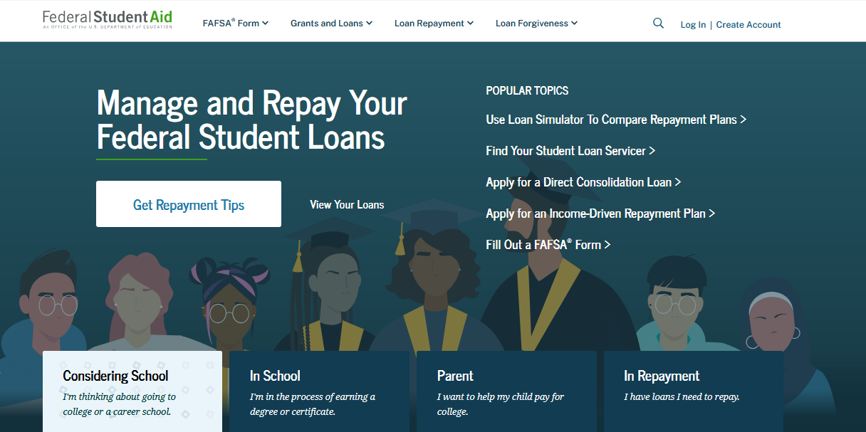

Objective #4: Recognize common pitfalls and learn how to address everyday family and financial situations.
Student Portion
The student will log in with their FSA ID; once verified, a student may use their email address and/or cell phone number in place of the username.
After logging in, the student will receive a two-factor verification code via email or text message. Access to one or both is necessary when filing the FAFSA.

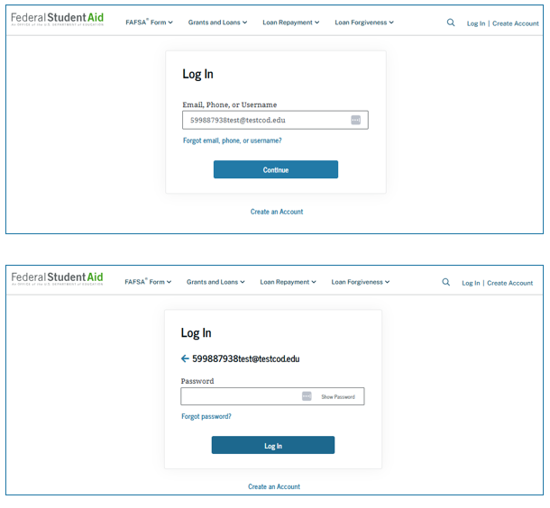

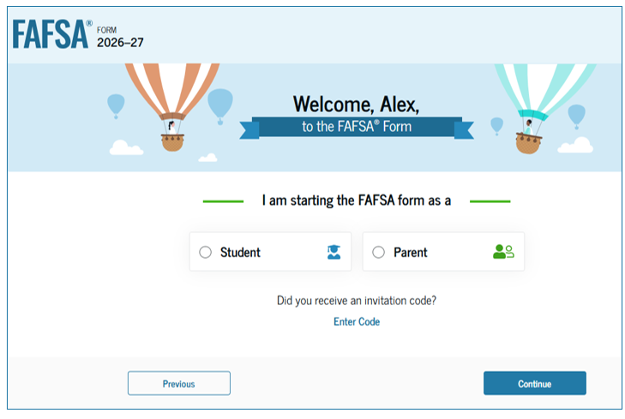
As a reminder, the FAFSA belongs to the student. Once the student has logged in, they will indicate they are beginning the form in the role of student.
Students will only see questions that directly relate to them and their finances.

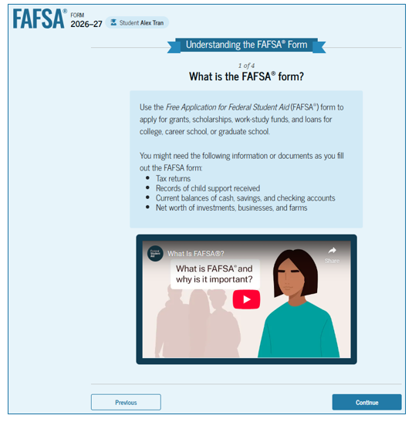
A first-time FAFSA filer will first view Federal Student Aid’s “onboarding.” This process will walk a student through four steps to understanding the FAFSA:
- What is the FAFSA form?
- Contributors to the FAFSA form
- What to Expect
- After Submitting the FAFSA form
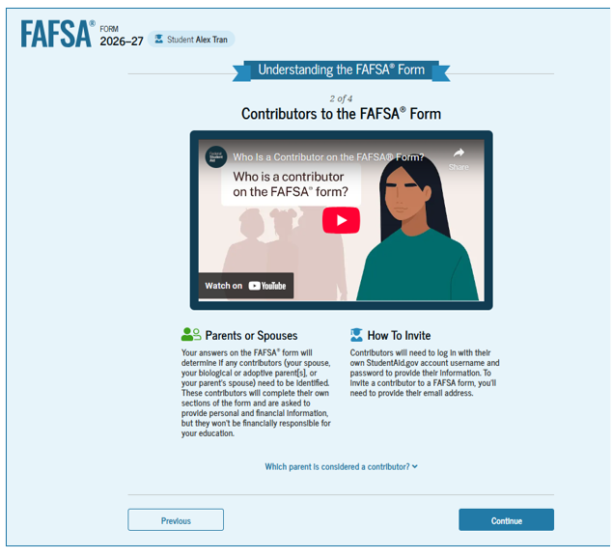
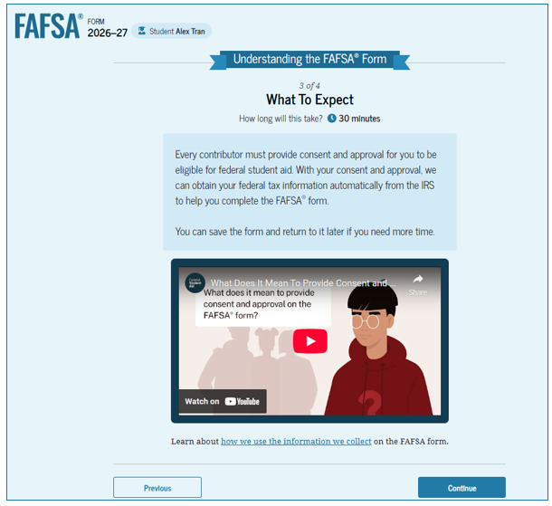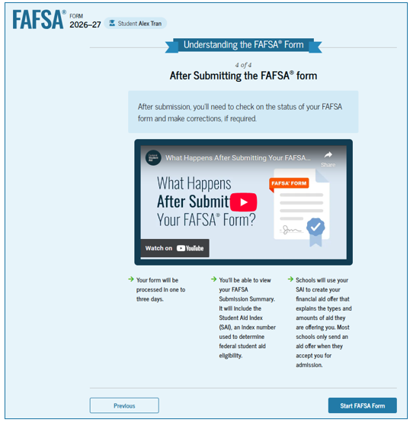

Before beginning the rest of the form, students will review their identity information. Please be aware that none of this information can be changed anywhere but Account Settings.

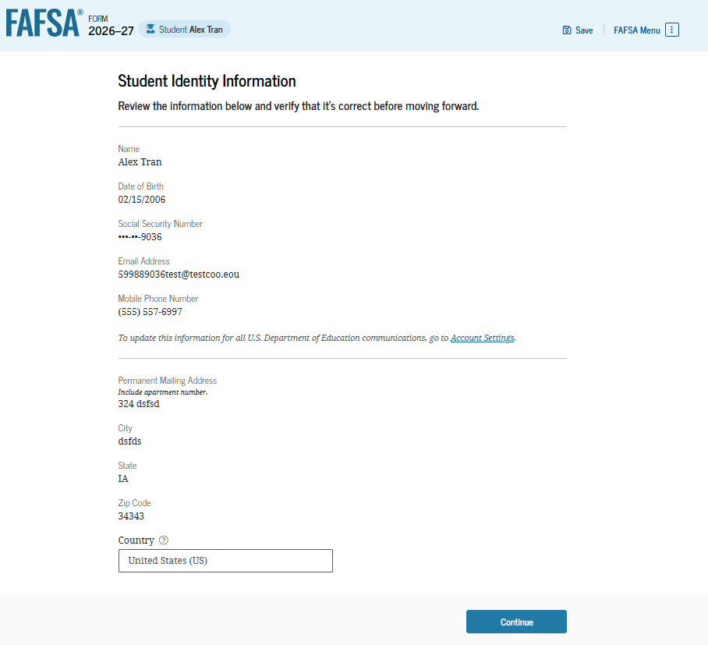

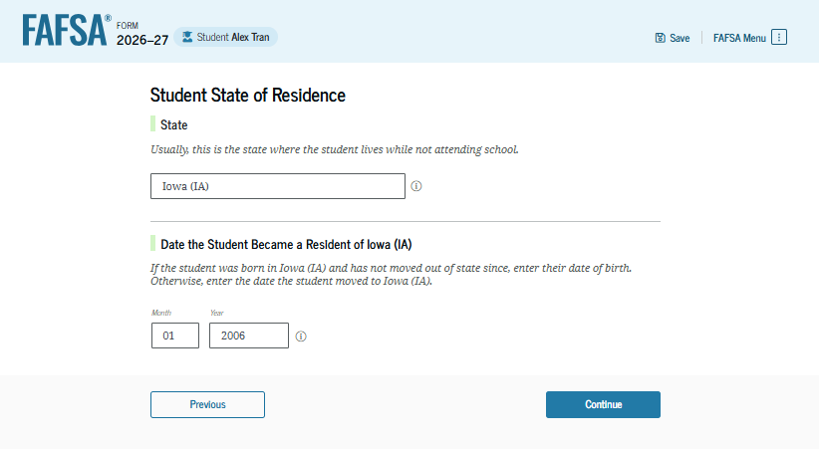

Every contributor, including the student, will be required to provide consent for their Federal Tax Information (FTI), whatever it is, to be retrieved from the IRS and shared with Federal Student Aid for the purposes of calculating the Student Aid Index and awarding financial aid.
No one should provide consent for anyone but themselves.
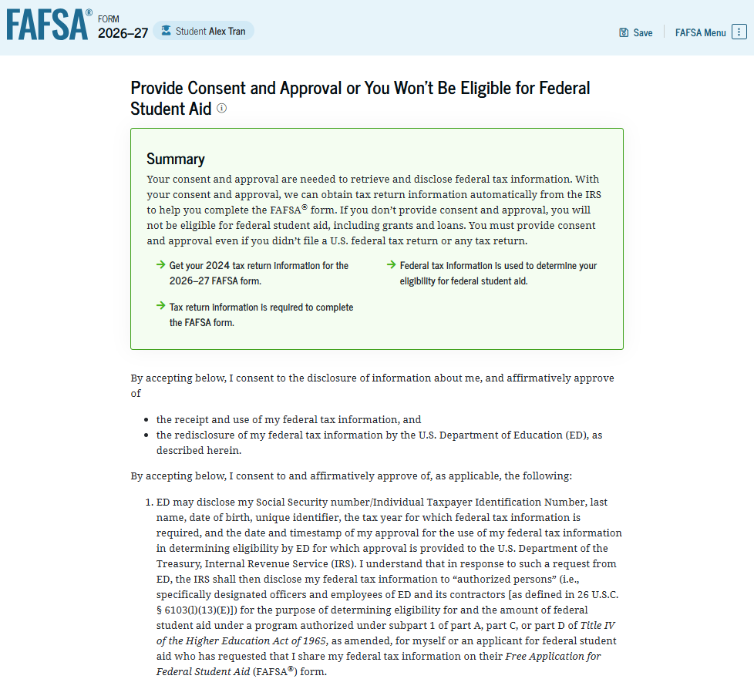
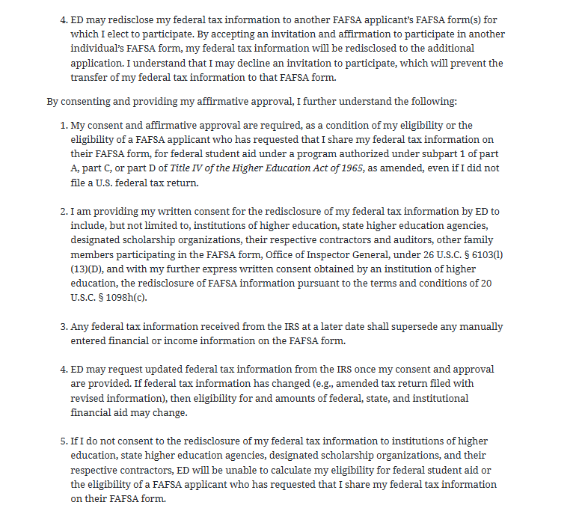
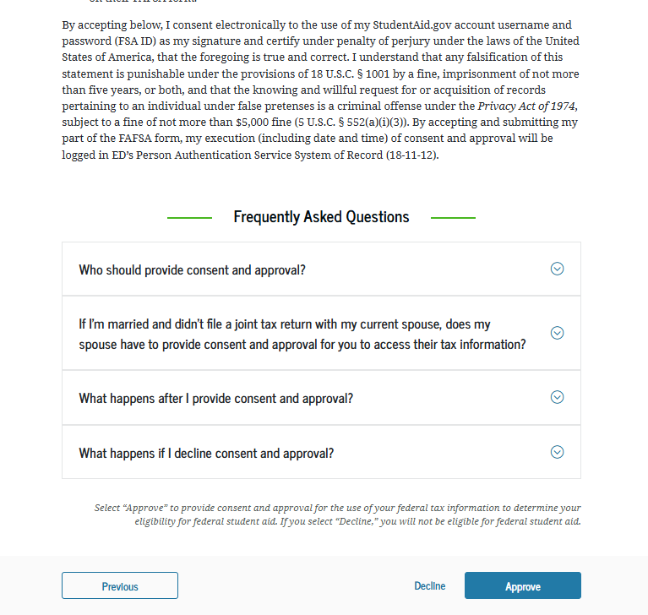

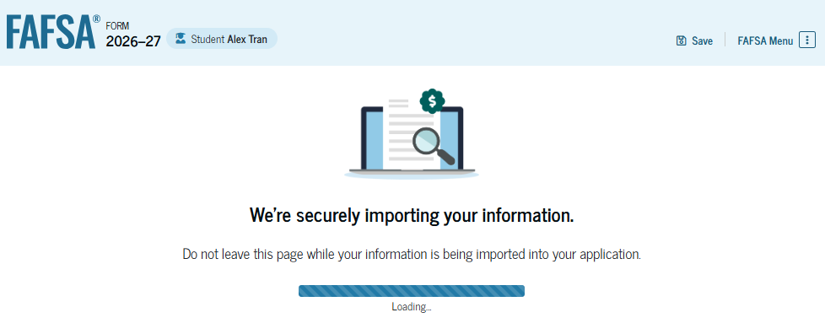

As a reminder, an individual may decline to provide consent for use of their FTI. However, if consent is not provided for a contributor on the FAFSA (student, parent, other parent, or spouse), the student will be ineligible for financial aid.
Questions related to personal circumstances help determine if a student is dependent or independent. A dependent student is required to provide parent(s) information on the FAFSA to be considered for financial aid; an independent student does not. See more about dependency questions on page 48.
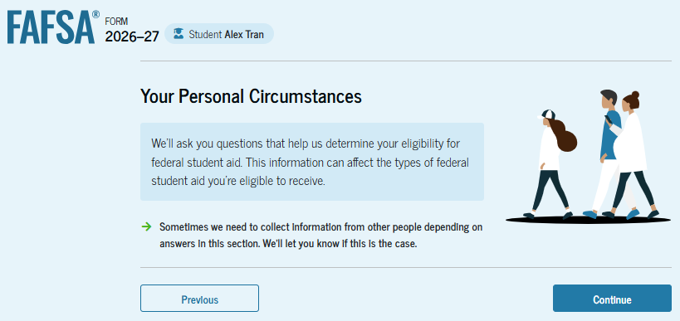

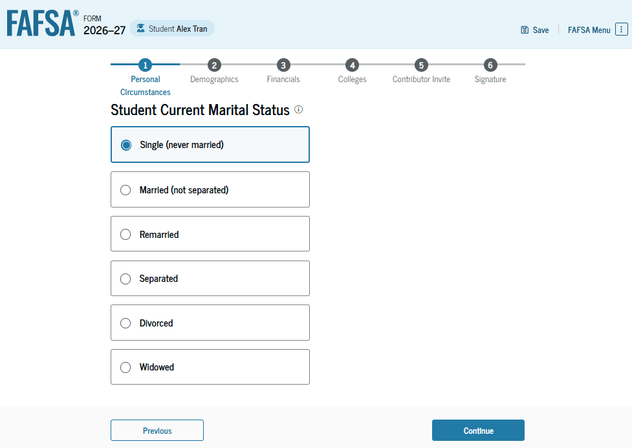
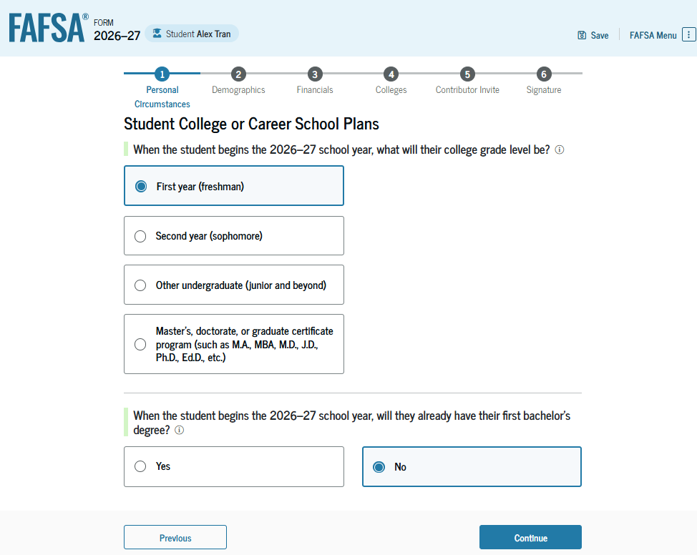
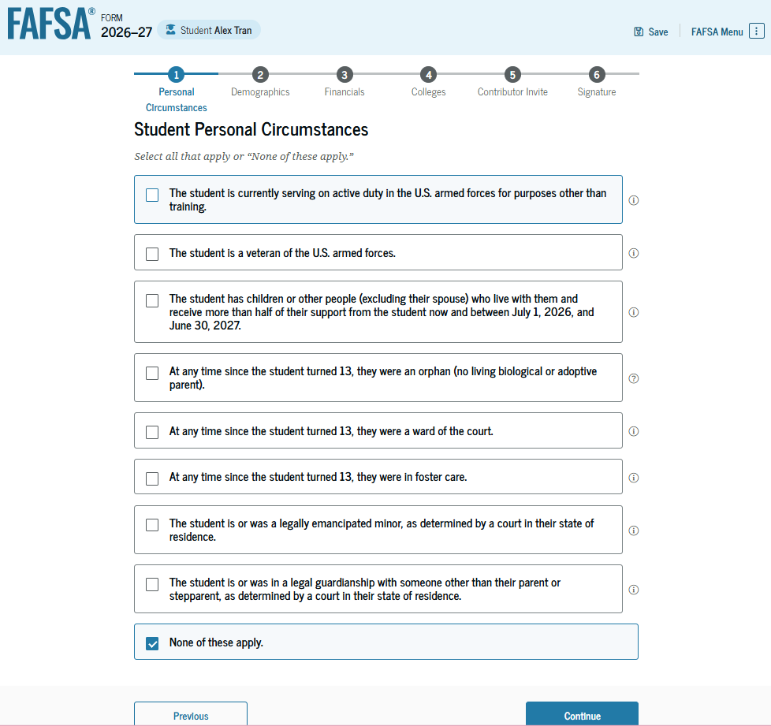
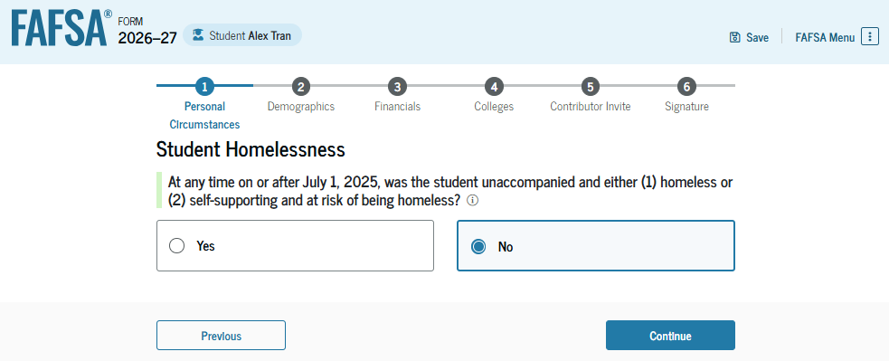
Students who are under the age of 24, unmarried, do not yet have a bachelor's degree, and who cannot answer “yes” to any of the personal circumstances questions are likely to be considered dependent and will require the information of their parent(s). The parent(s) will be invited as contributors to the student’s FAFSA.
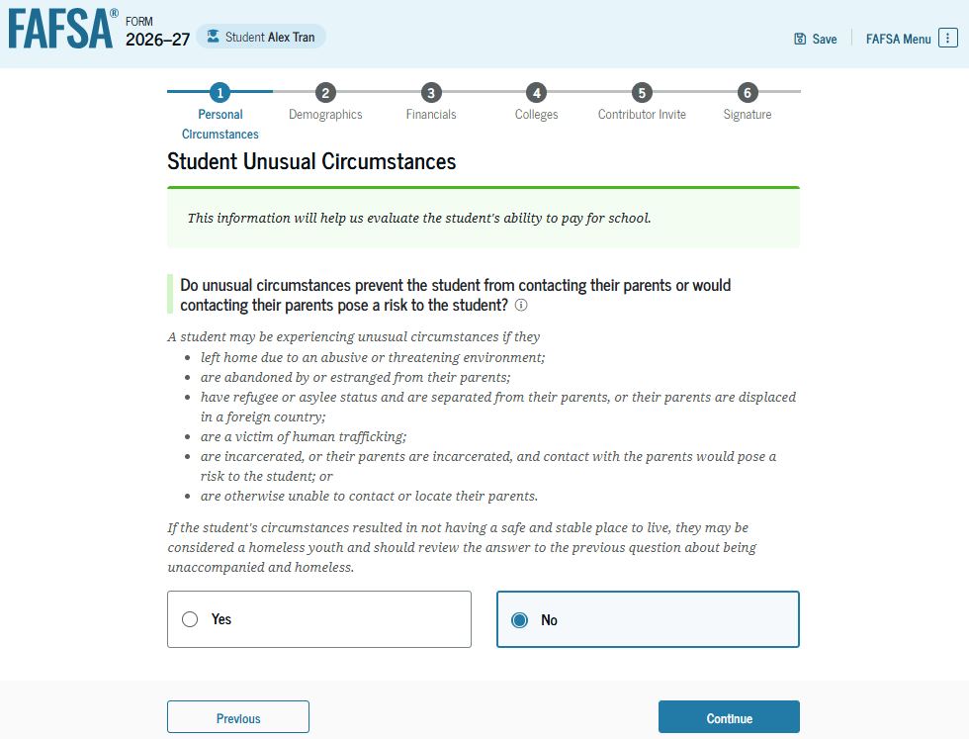
Federal Student Aid recognizes that some students may not meet the definition of an independent student but will be unable to invite their parent(s) to contribute to the FAFSA. This is referred to as “unusual circumstances” and students who may have a circumstance that prevents them from obtaining parent information my able to file the FAFSA as provisionally independent student and request their prospective college(s) consider them for a dependency override.
A provisionally independent student status will allow a student to submit their FAFSA without inviting parent(s) to contribute. The FAFSA will calculate a provisional Student Aid Index (SAI); however, the student must follow up with the college’s financial aid office and provide documentation to verify their circumstances.
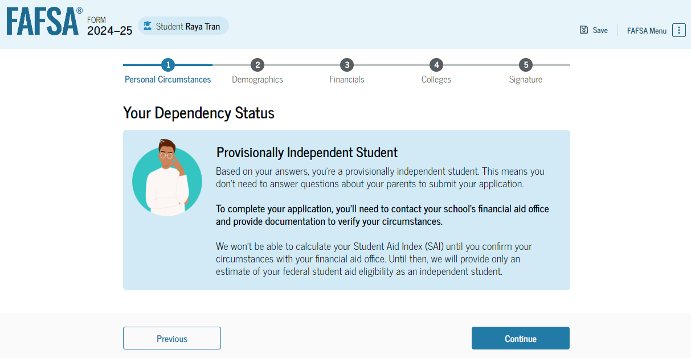

Students who are considered dependent who cannot obtain the information of their parent(s) for the FAFSA, and who do not have circumstances that qualify them for provisional independent status and, ultimately, a dependency override, may submit their FAFSA without parent information. However, they would be eligible to apply only for a Direct Unsubsidized Loan.
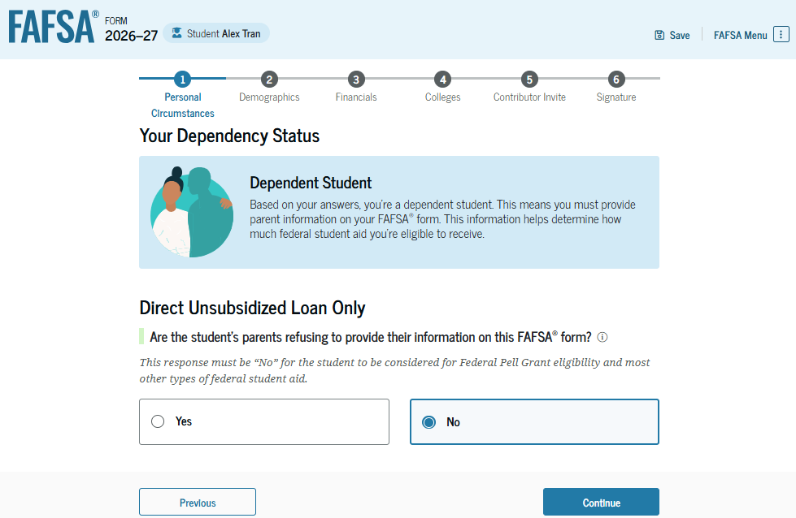
If the student lives with both parents and they filed their taxes together, students may invite both parents, although only one parent will need to serve as the contributor. Either parent can then serve as the contributor and provide the necessary consent for the student’s FAFSA.
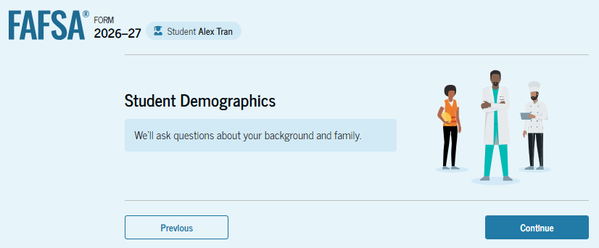
The FAFSA does ask students to provide demographic information. It is important to note that responses to the questions related to race and gender will not be used to determine student’s aid eligibility; are not shared with colleges or state agencies; and are not listed on the FAFSA submission summary. These questions, and the responses, are visible only to the student.
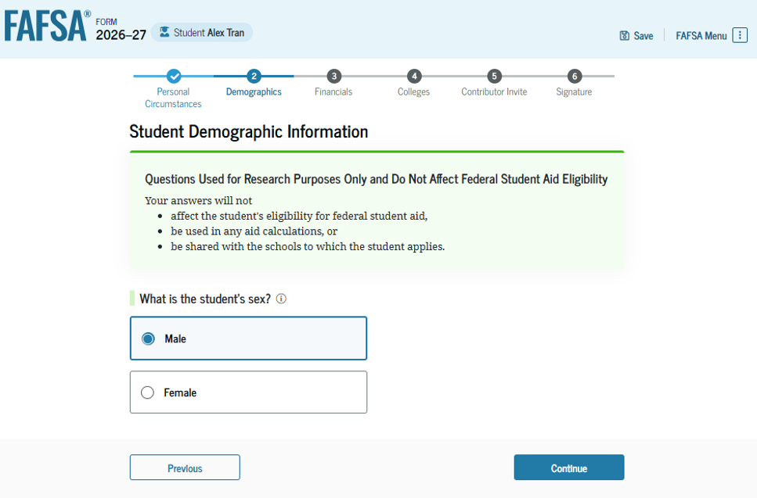

Please note: These images all reflect “prefer not to answer.” These are FSA screenshots, and the images are not intended to be perceived as a recommendation on how to respond to these questions.
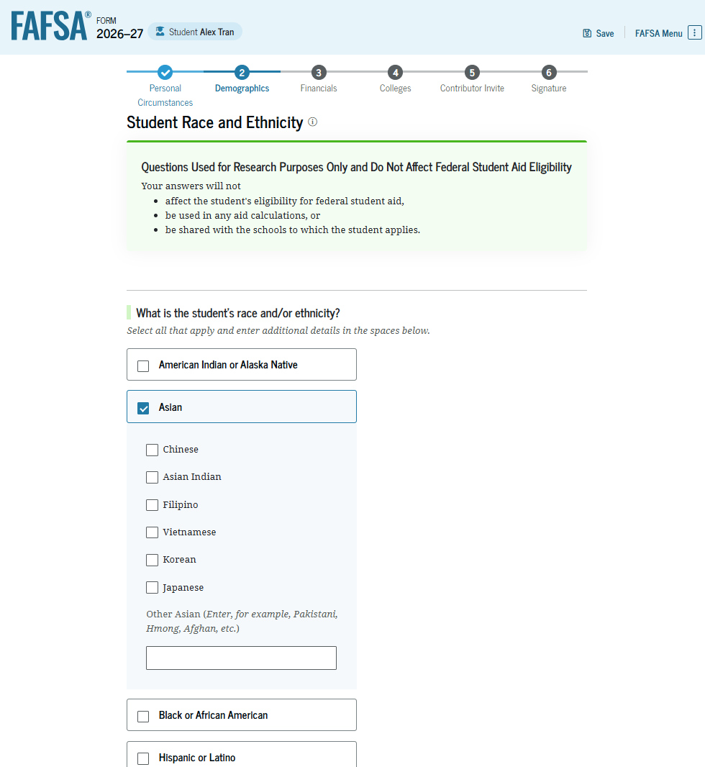

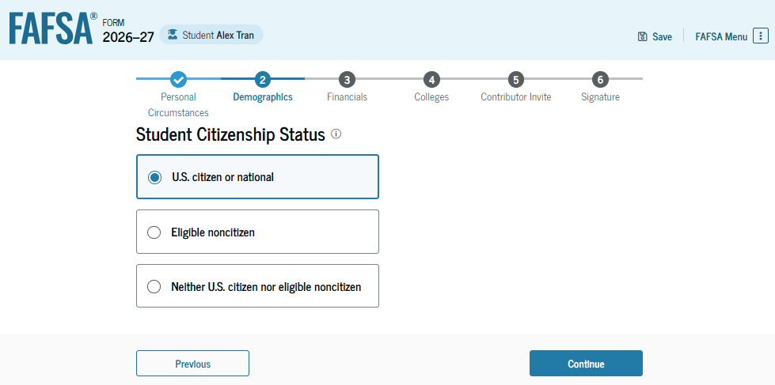
As the primary financial aid application, filing the FAFSA is critical for students eligible to do so. All U.S. citizens are eligible, as well as eligible noncitizens. Eligible noncitizens include those who have legal permanent residence (green card holders). In addition, individuals with an Arrival-Departure Record (I-94) from U.S. Citizen and Immigrant Services (USCIS) showing any of the following may also be eligible to file the FAFSA: refugee, asylum granted, Cuban-Haitian Entrant, or parolee.
Students who are undocumented, including those approved for Deferred Action for Childhood Arrivals (DACA), are not eligible for federal student aid. Students who wish to speak with someone about financial aid opportunities are encouraged to contact The Scholarship Foundation for information and assistance.

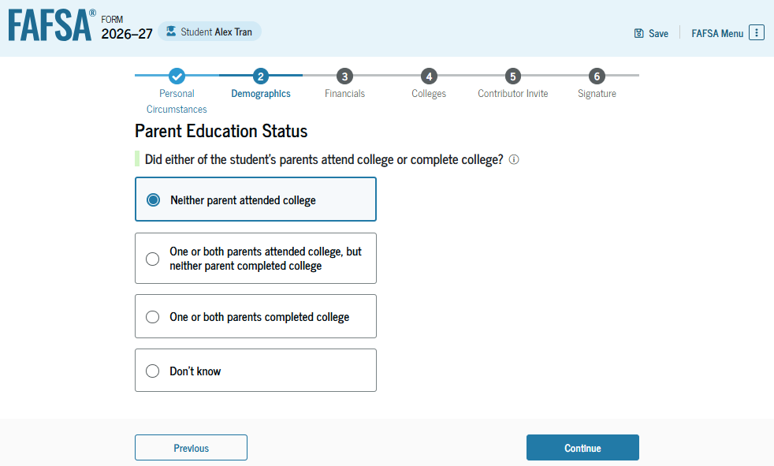

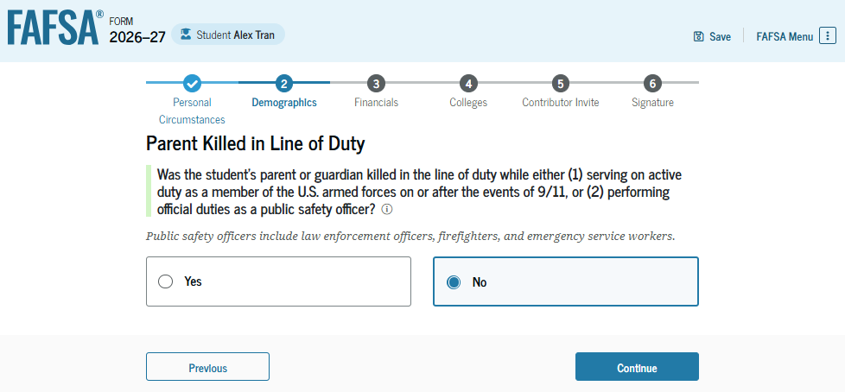
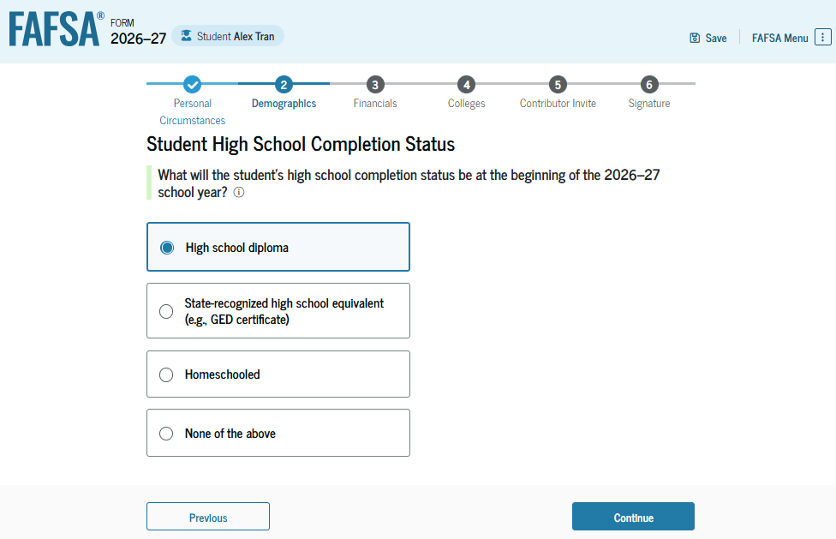

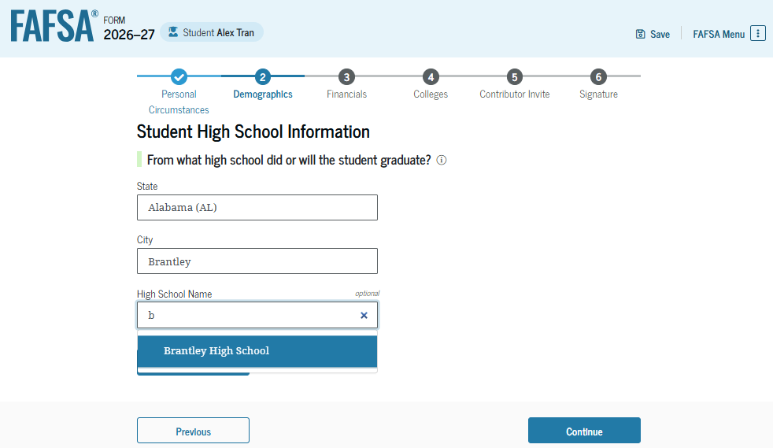

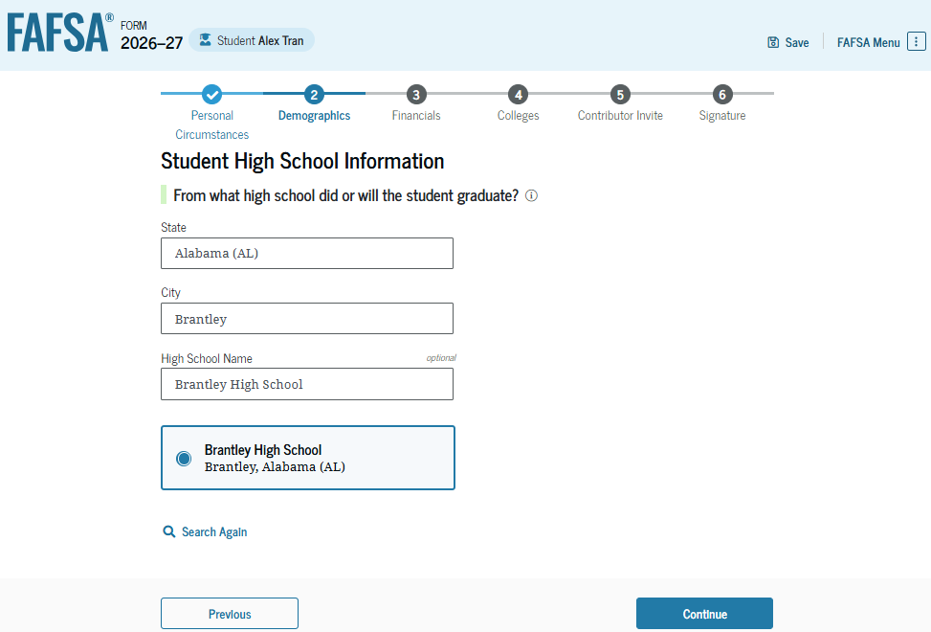

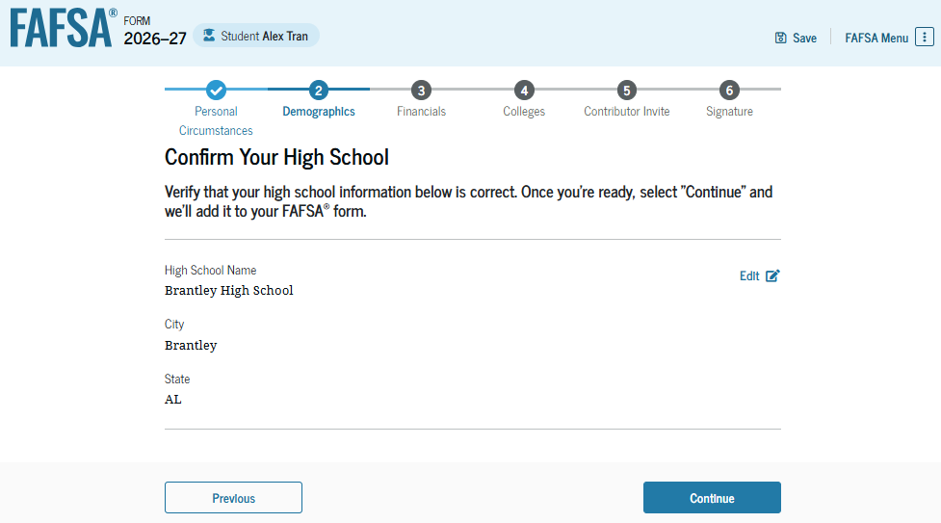
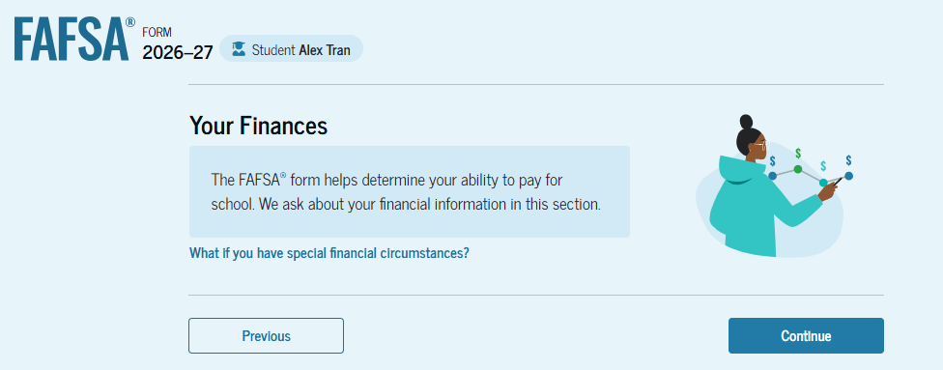

Although most FTI will be shared directly from the IRS through a direct data exchange, tax filers should have relevant tax information on hand when they file the FAFSA, as some questions may still require referencing the tax return for the answer.
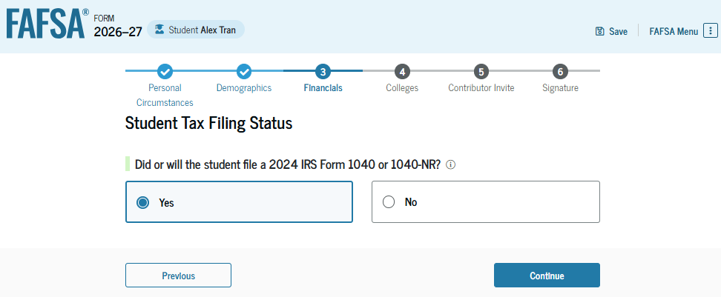
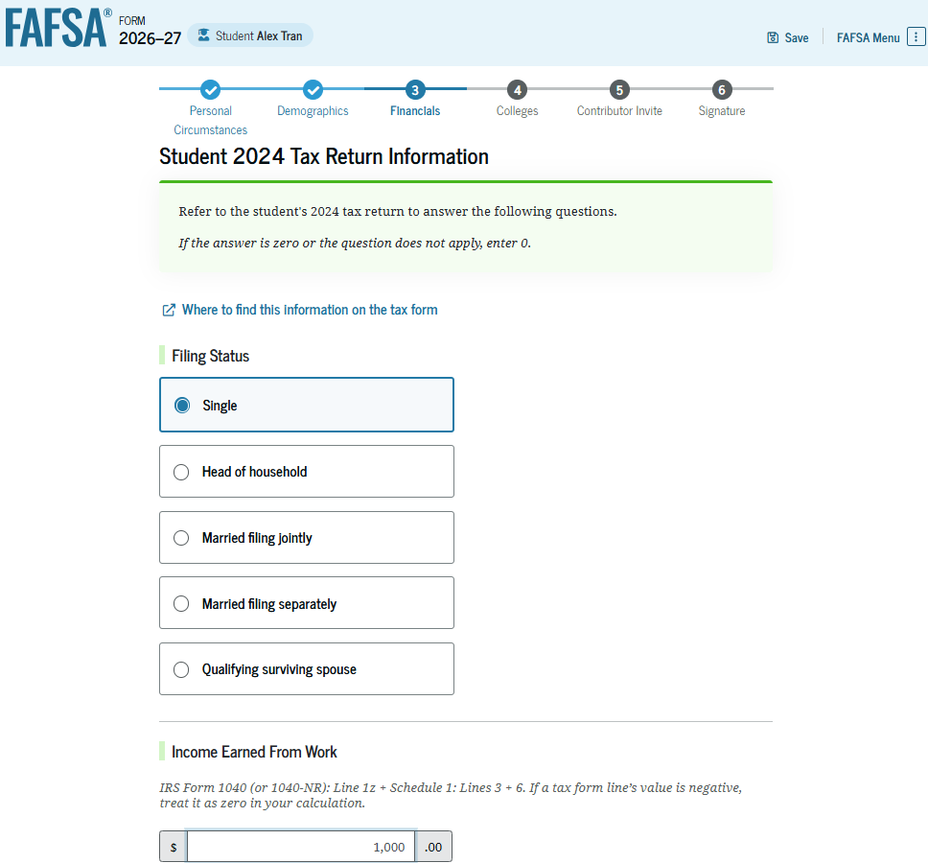
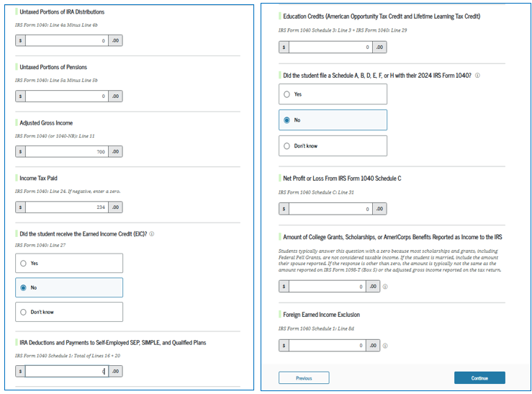
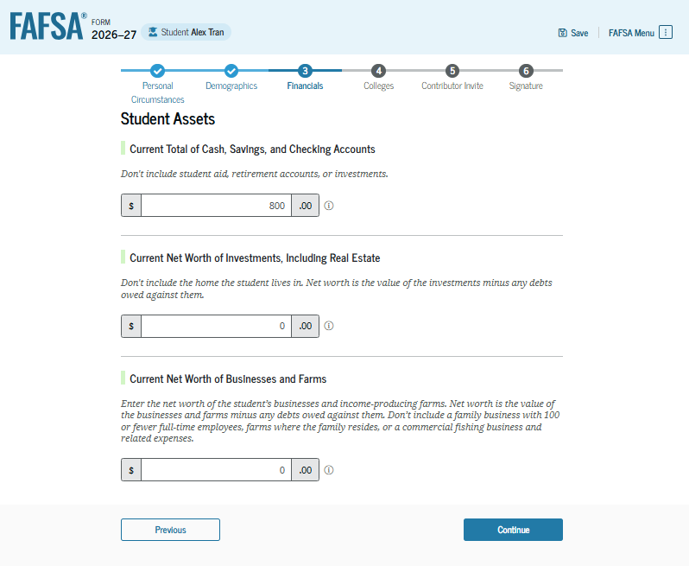
Students will only see the asset questions if they complete their entire portion first and/or if their parent(s) are not exempt from asset reporting. If the student provides responses to these questions and it is later determined the household is exempt from asset reporting, the information will be excluded from the SAI calculation. Students are exempt from asset reporting if:
- The applicant qualifies for a maximum Pell Grant.
- The applicant’s parent(s) adjusted gross income is less than $60,000 and they did not meet additional tax-filing conditions.
- The applicant or their parent received a benefit under a means-tested Federal benefit program during the 2024 or 2025 calendar year.

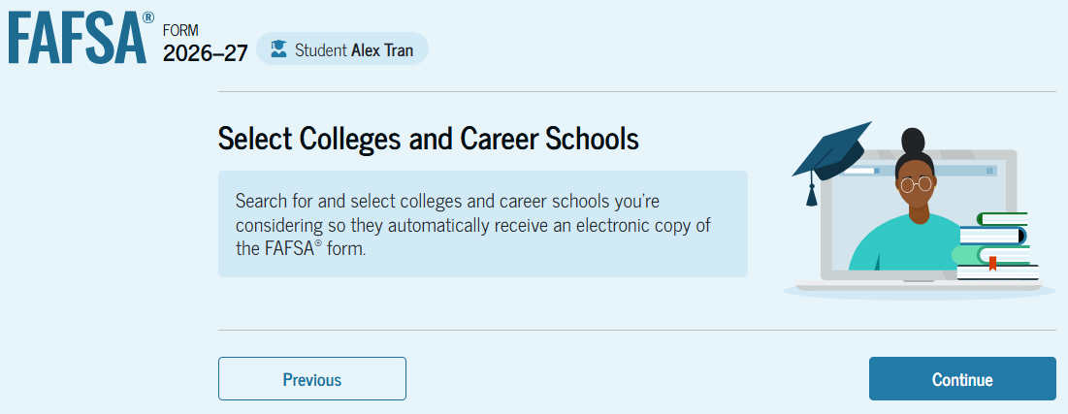
Students may list up to 20 colleges on their FAFSA and they should list any colleges they have already applied to, as well as any they may still apply to for admission. Students may always return to their FAFSA and amend this list, adding or removing as necessary. In some states, the order of schools does matter for consideration of state financial assistance. The FAFSA will now provide guidance appropriate to students if their state of legal residence has any eligibility requirements. The schools listed will not be able to see what other colleges a student has listed on their FAFSA.
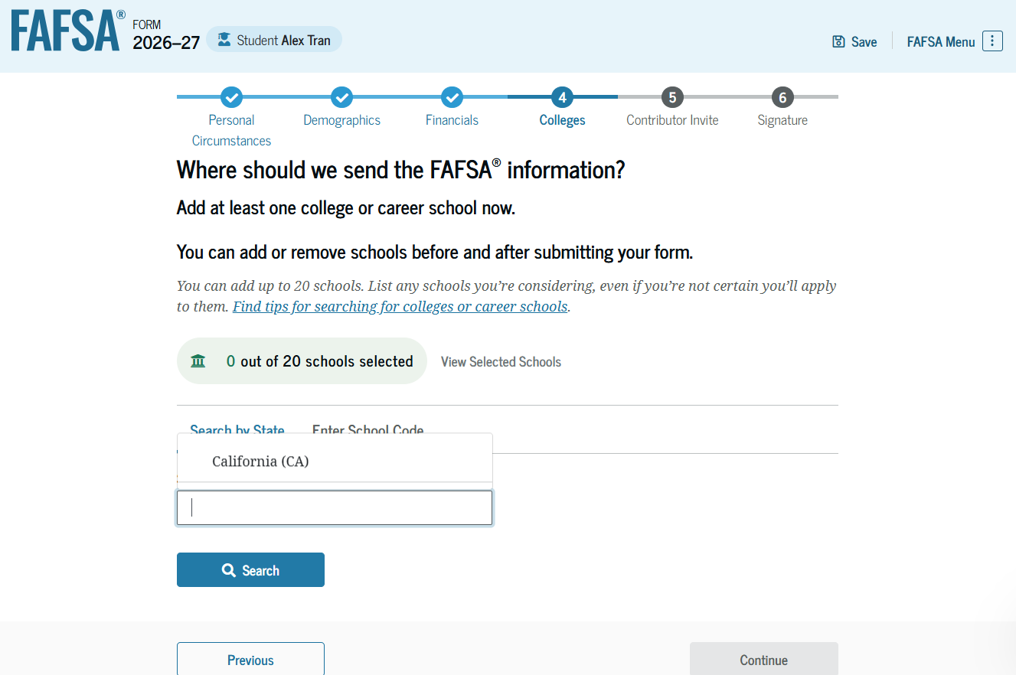
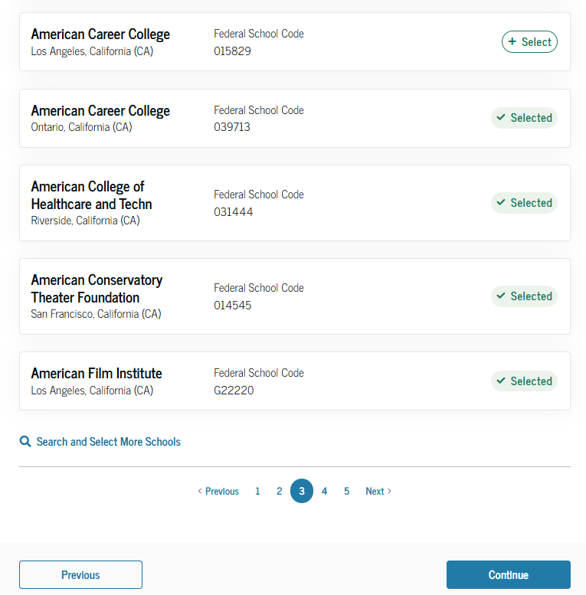
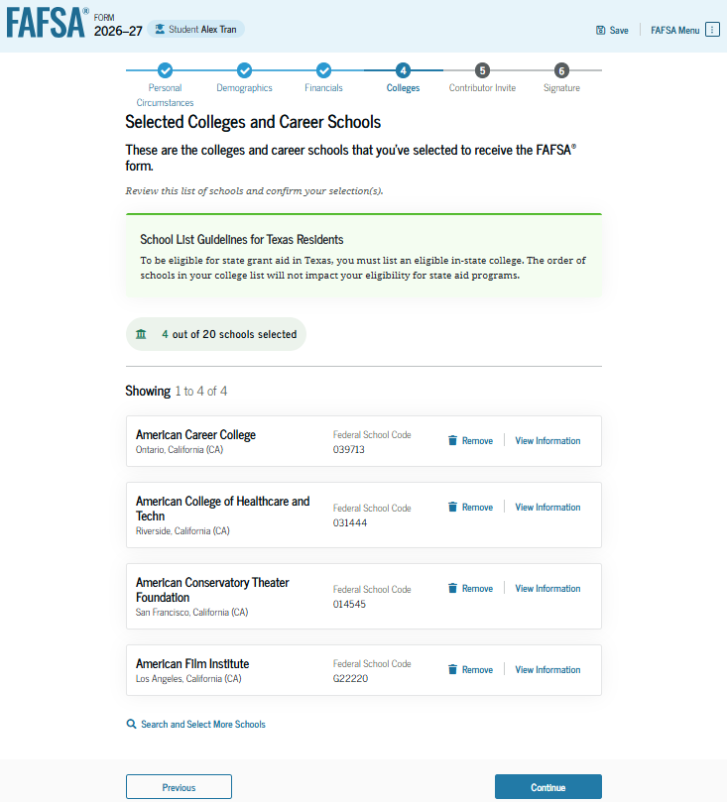

When a student is dependent and can invite their parent(s) to contribute, they will be prompted to enter their parent’s email, so an invite code will be sent. The FAFSA form will include a parent wizard, which will help guide the student in determining which parent(s) must be invited to contribute to their FAFSA.
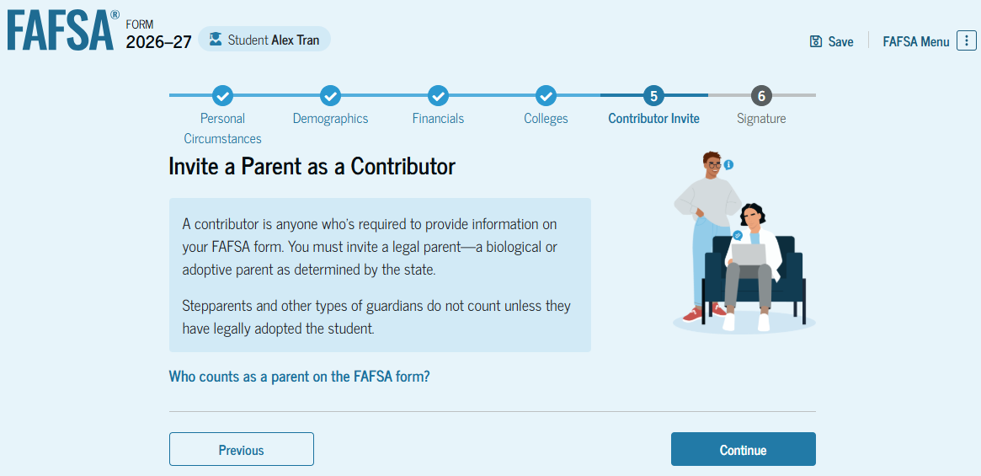

Depending on the marital and tax filing statuses of the student’s parents, one or both may need to contribute. Outlined below are some examples.
If the student’s parents are married and filed their federal taxes using a married-joint tax return, only one parent will be required to create an FSA ID, act as a contributor, and provide consent.
If the student’s parents are married and filed their federal taxes using a married-separate tax return, both parents will be required to create an FSA ID, act as contributors, and provide consent.
If the student’s parents are divorced, the student will need to determine which parent provides more than 50% of the financial support.
If the student’s parents are unmarried but living together in one household, both parents will be required to create an FSA ID, act as a contributor, and provide consent.
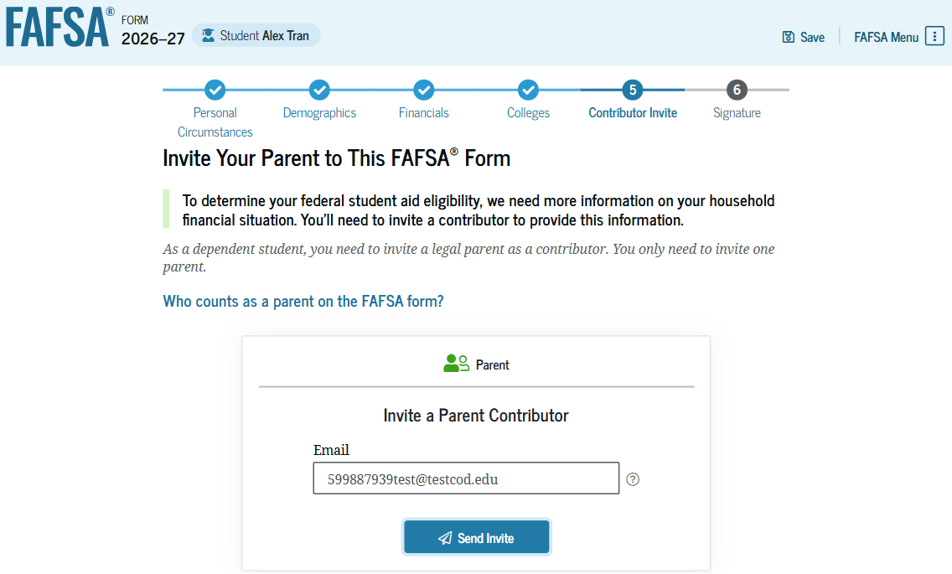
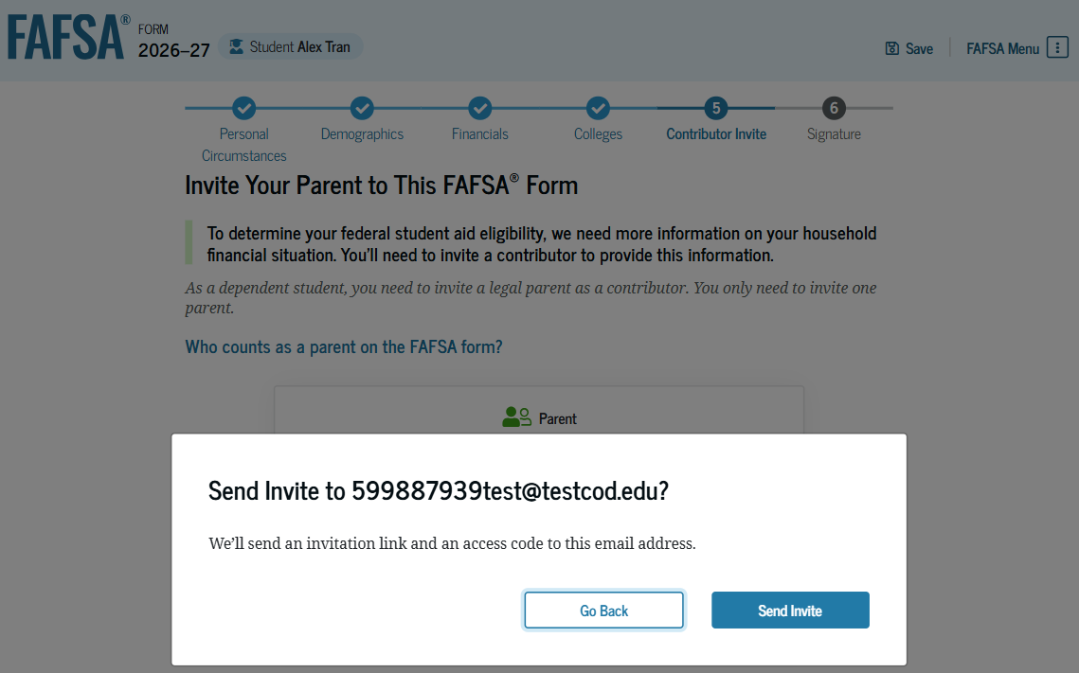
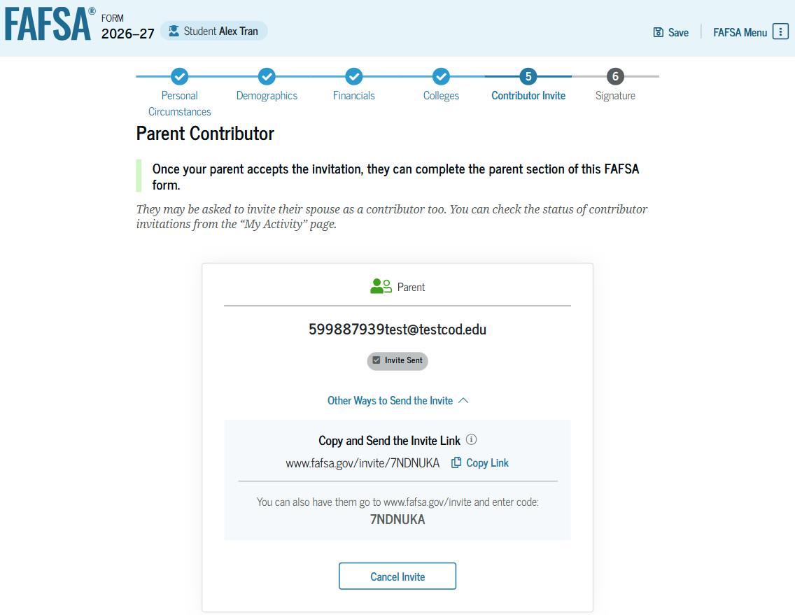

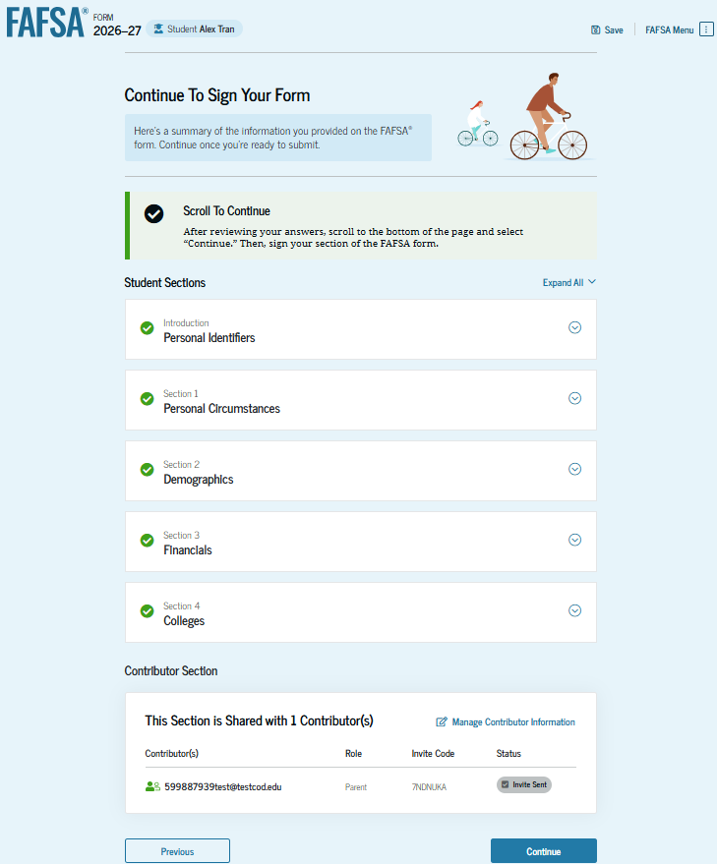
Students will be able to review, and edit, if necessary, the information for their contributors before submitting the FAFSA.
Remember, the FAFSA cannot be processed until any required contributor(s) have provided their information, including consent for use of FTI.

Finally, students will be asked to sign and submit. As with the consent for use of FTI, students should read this page before using their FSA ID to sign and submit.

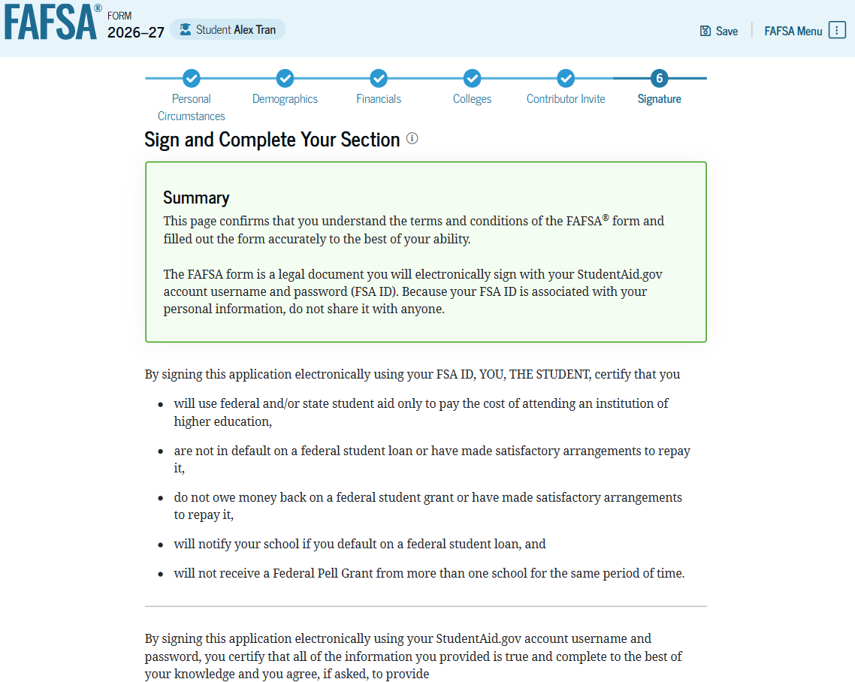
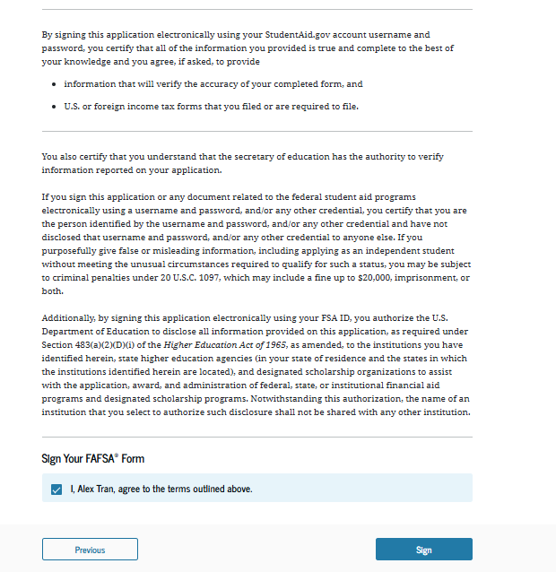
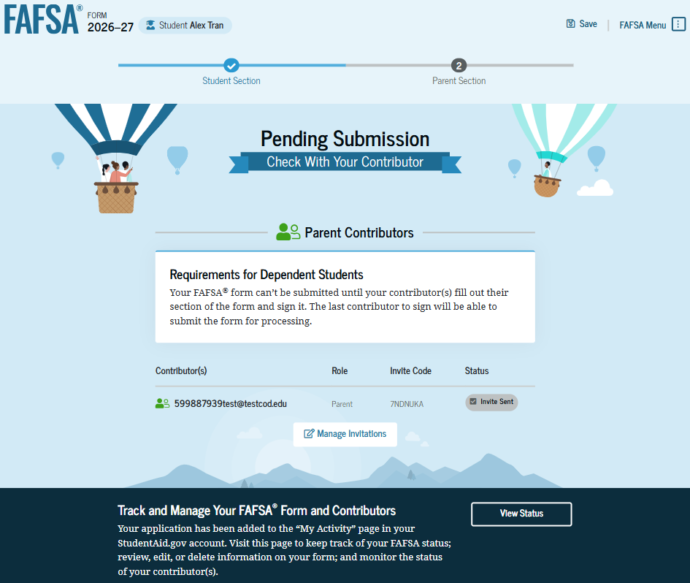
After completing the student portion of the FAFSA, the applicant will see a confirmation page, which will include details about next steps and information about what the FAFSA Submission Summary is and how to access it.
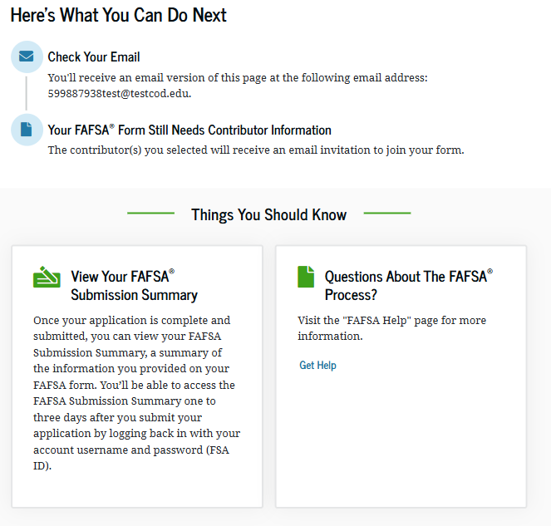

Objective #4: Recognize common pitfalls and learn how to address everyday family and financial situations.
Parent Portion
Parent contributors will receive an email invitation, which explains in more detail what they have been invited to complete, and why. Note that the student’s portion will be deleted after 45 days of inactivity, which would then require the student to return to their portion and do over.

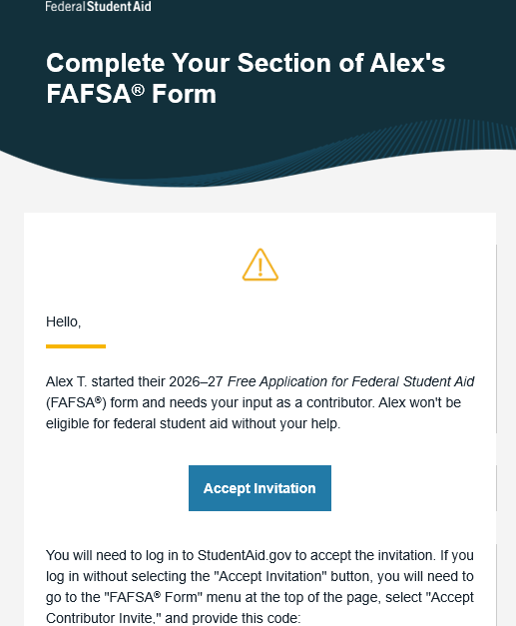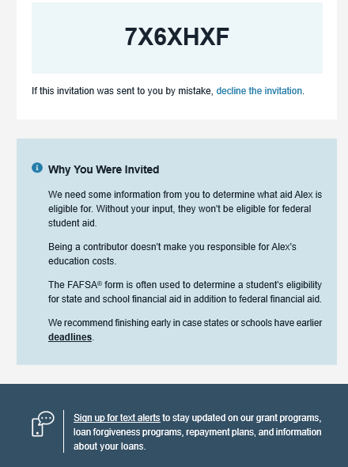
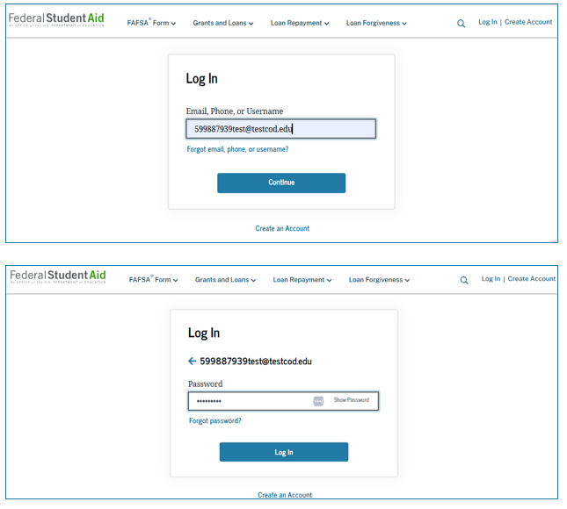
Like student applicants, contributors will be prompted to log in with their FSA ID username and password.
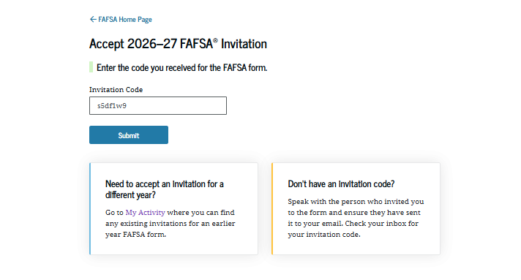
Individuals who have an existing relationship with Federal Student Aid may see details about other activities, past or present.
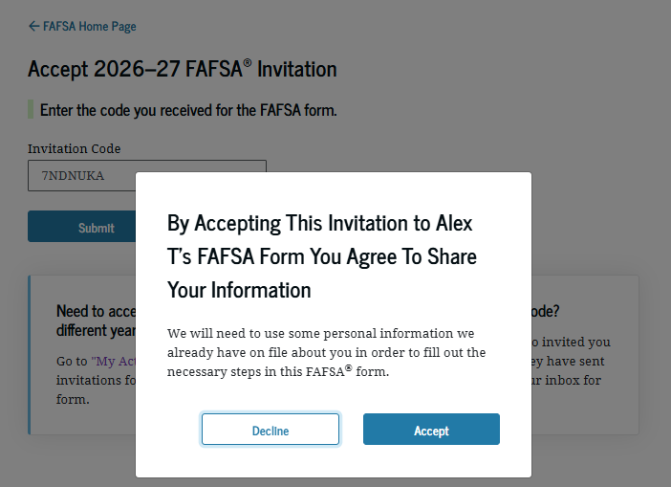
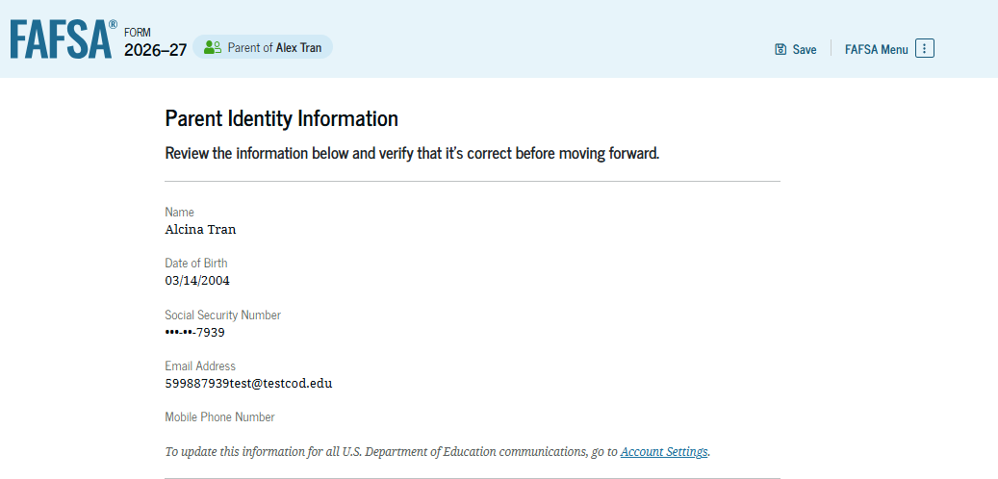
Parent contributors will also only be able to update their identity information in account settings.
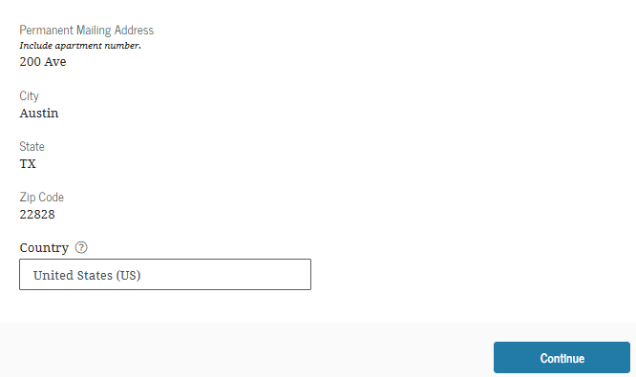
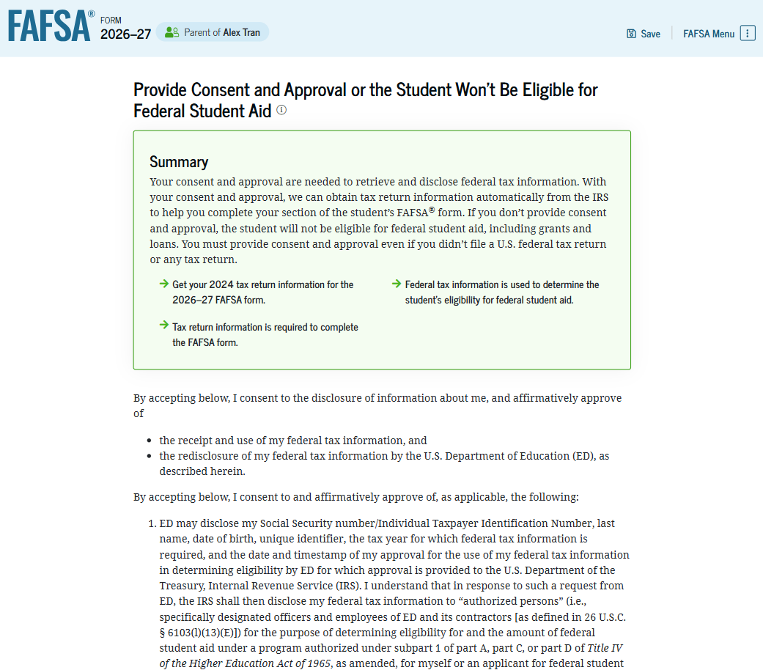
Every contributor must provide consent. Parent contributors can decline to provide consent, but the student will be ineligible for Federal Student Aid.
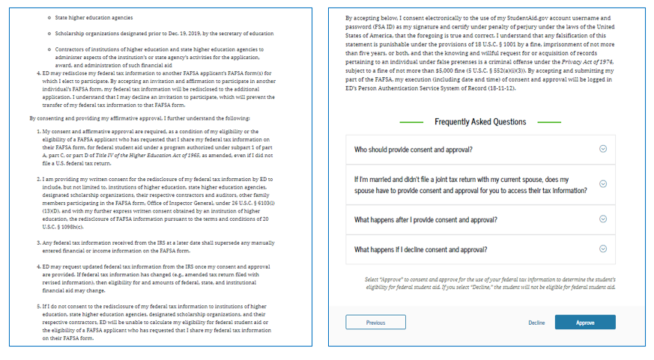

Parent contributors will also be prompted to provide some demographic information, but the information is different than what is required from students.

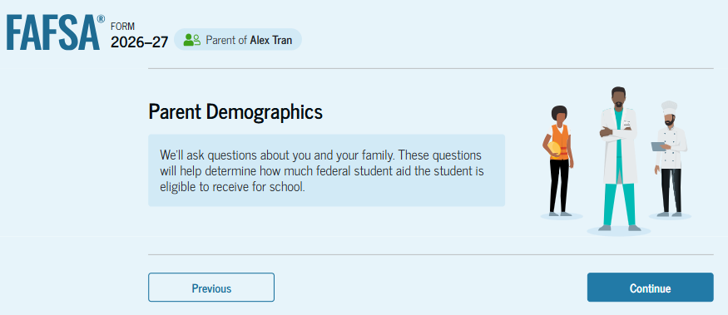
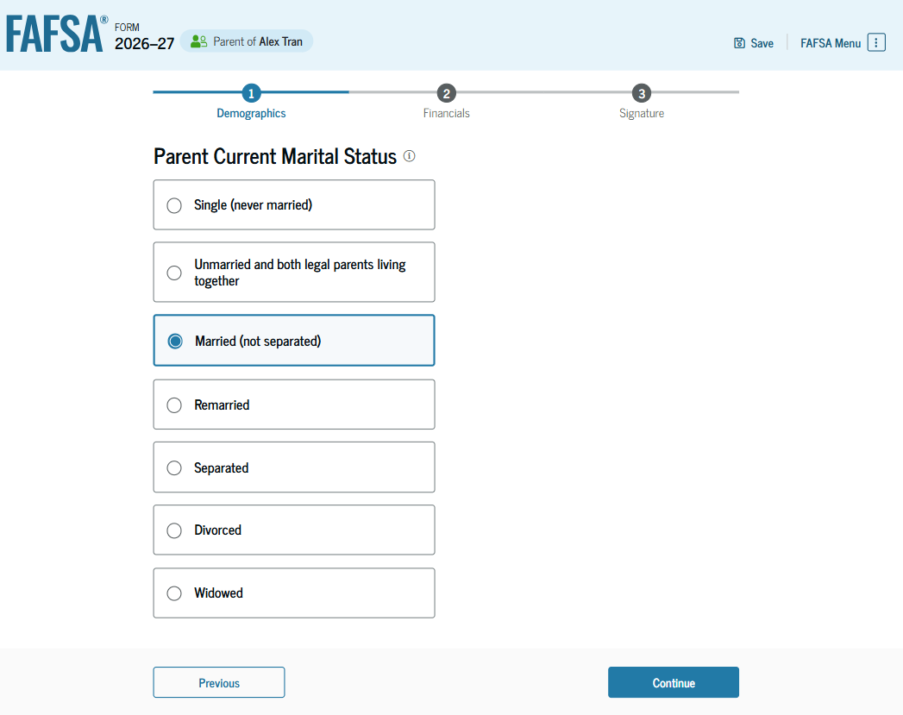
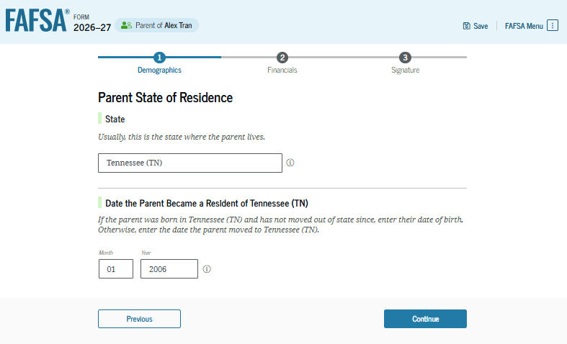
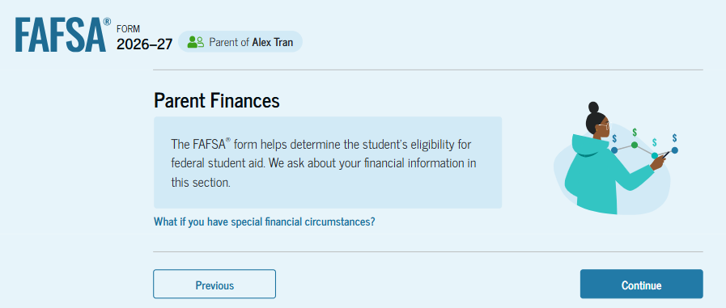
Parent financial information is an important part of the FAFSA. The parent contributor(s) will be prompted to answer the following questions related to their finances.
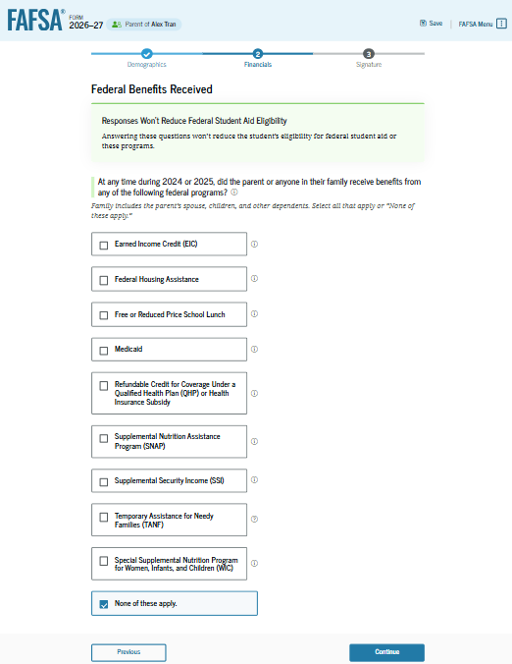

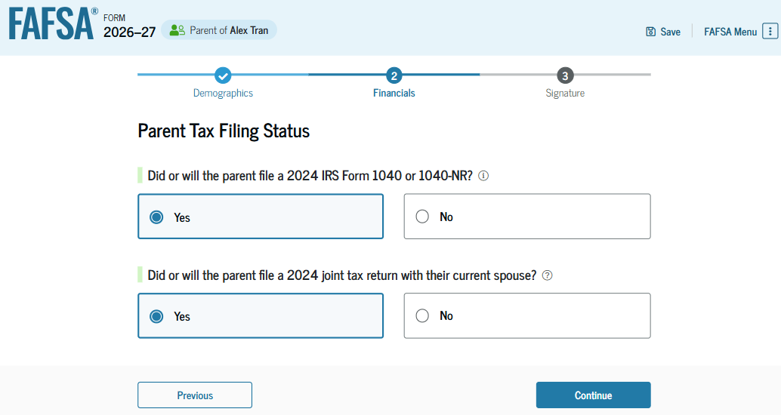
The marital and tax filing status of the parent(s) will confirm if all contributors are correctly accounted for on the student’s FASA.
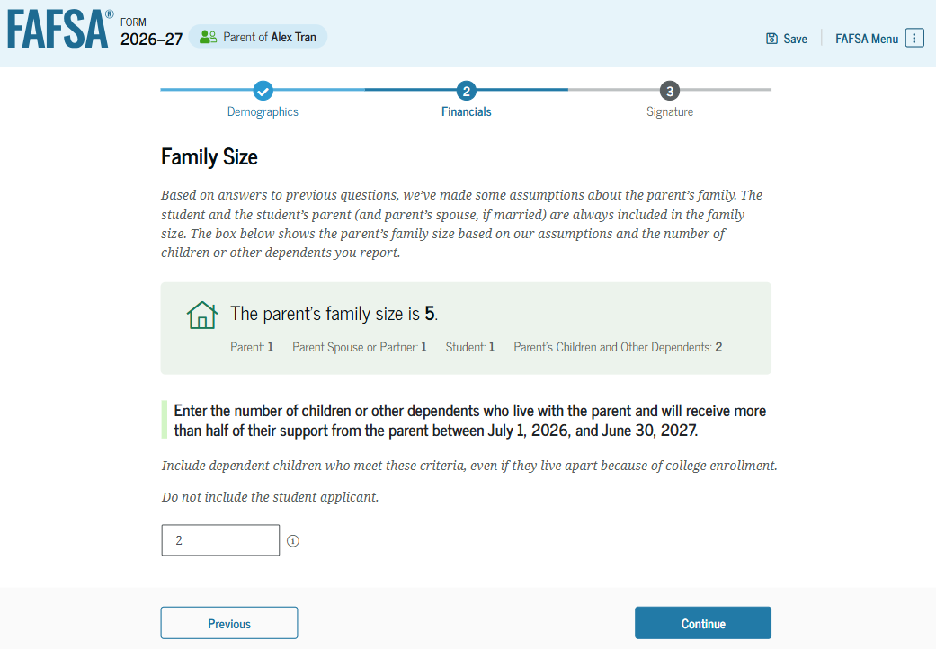
Although most tax information will be directly transferred from the IRS, some questions will require manual entry or allow for updated information to be provided. Family size is one item that parent contributors can update and so it is necessary to have tax returns on hand for reference when filing the FASFA.
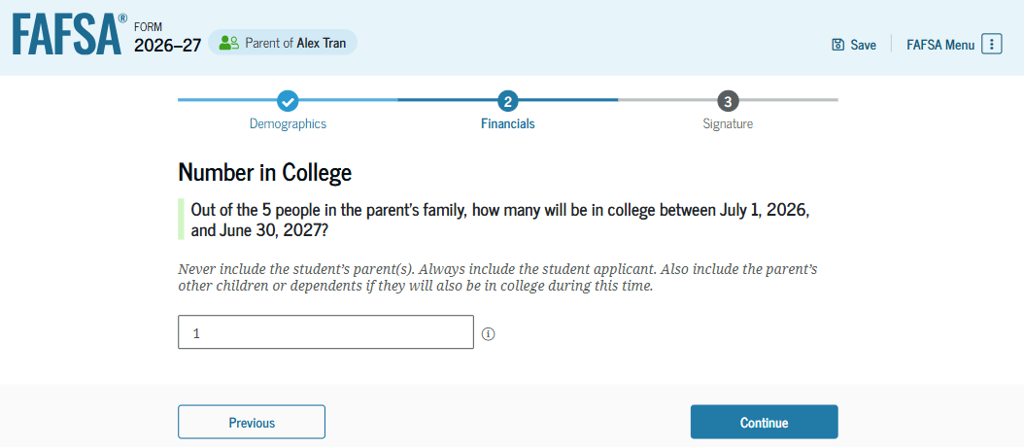
Please be aware that although the FAFSA asks about the number of household members, excluding parent(s), will be enrolled in college, this information is not a factor in determining the Student Aid Index or the student’s aid eligibility.
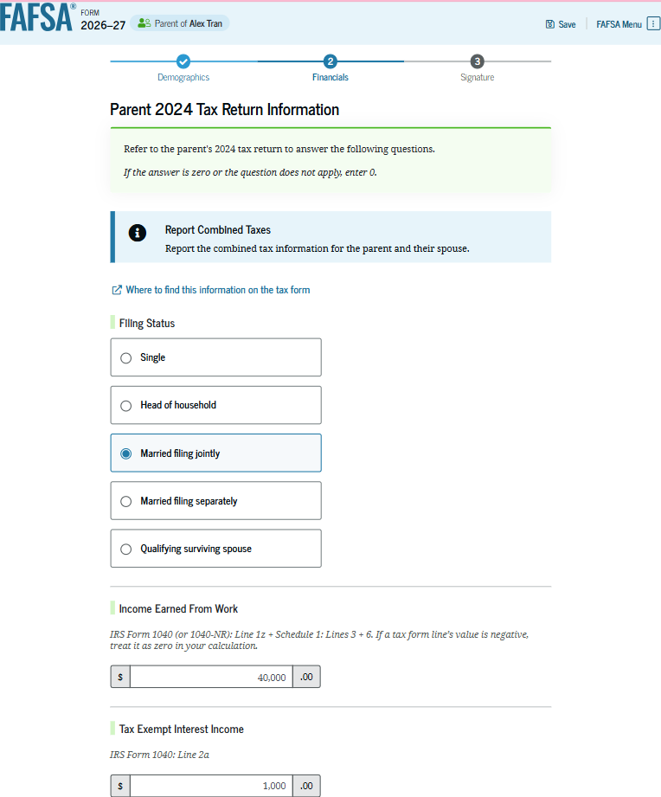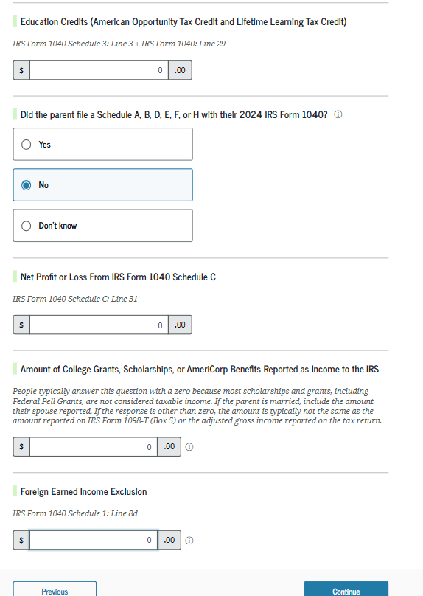

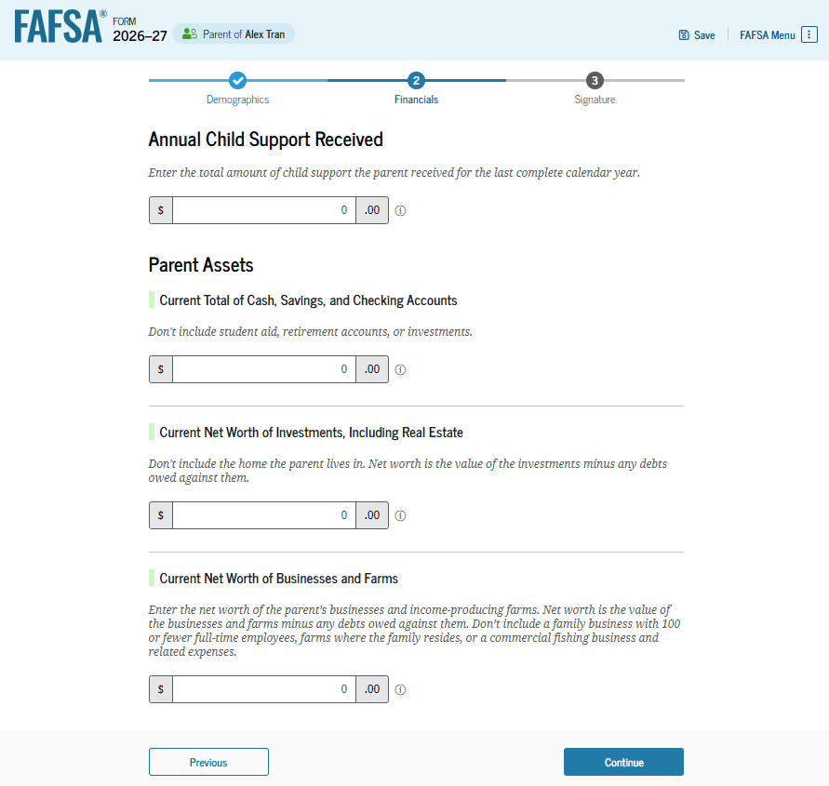
Some parent contributors will be exempt from reporting assets. However, those who are required to provide asset information should note the following:
- Child support received is an asset and is reported on the FAFSA if applicable.
- Small businesses with fewer than 100 employees and family farms are exempt starting with the 2026-27 FAFSA, and do not need to be included in the net worth of investments.
- Parent contributors must also report the net worth of any investments; please note that this question specifically excludes the value of the home the family lives in, as well as retirement accounts (401K, 403B, etc.). Please carefully review information about investments that are required.
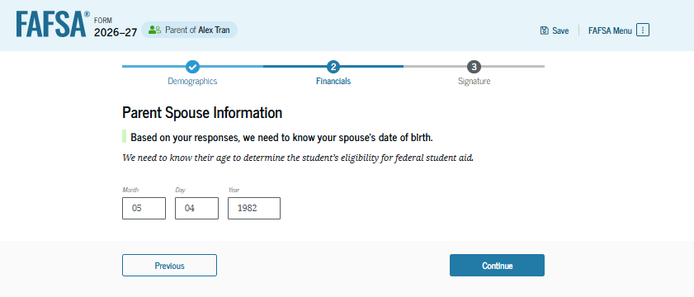
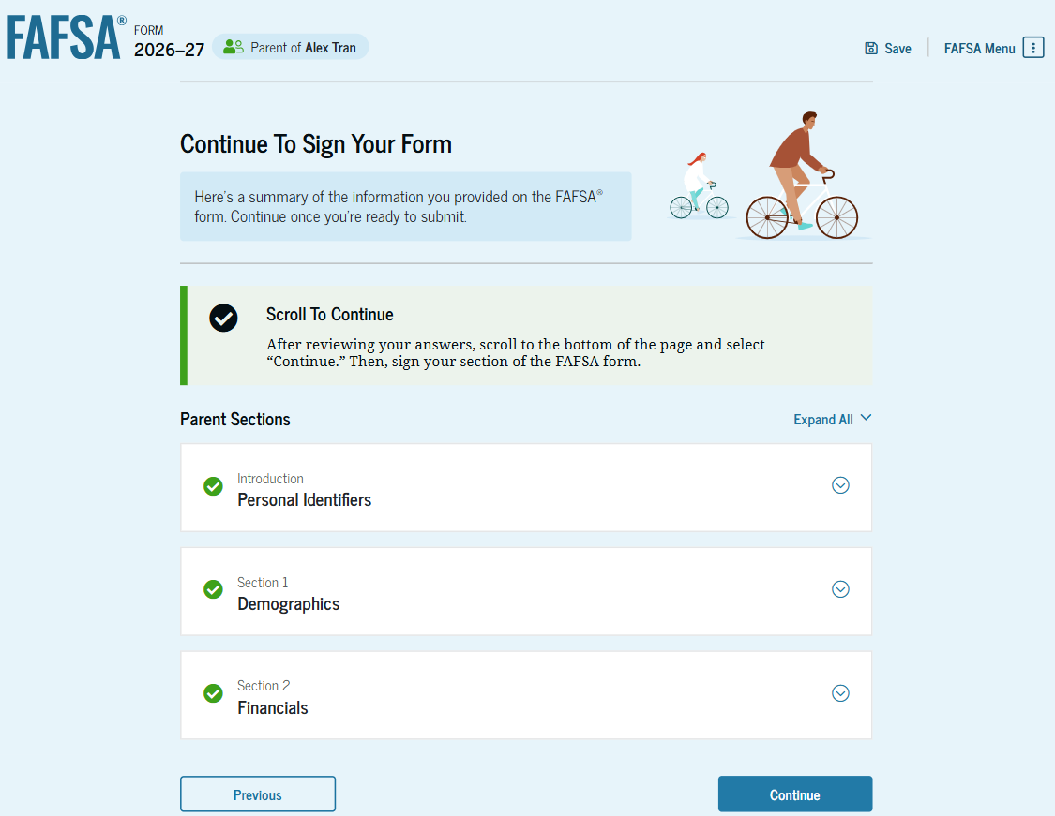
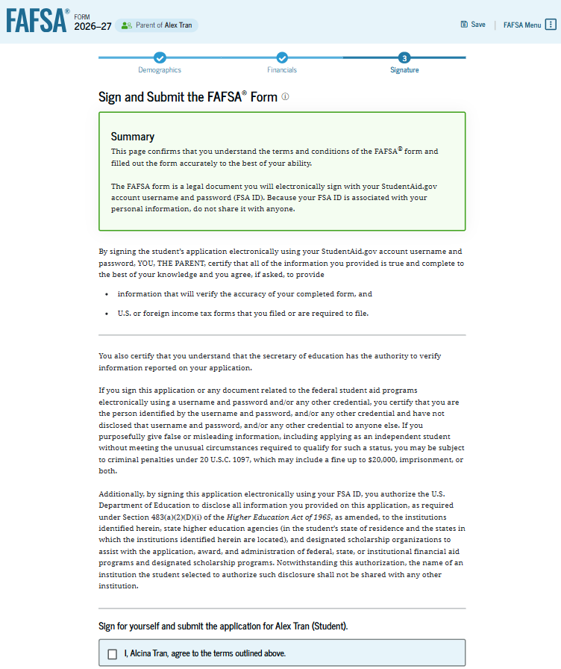
The parent contributor(s) must also sign using their FSA ID.
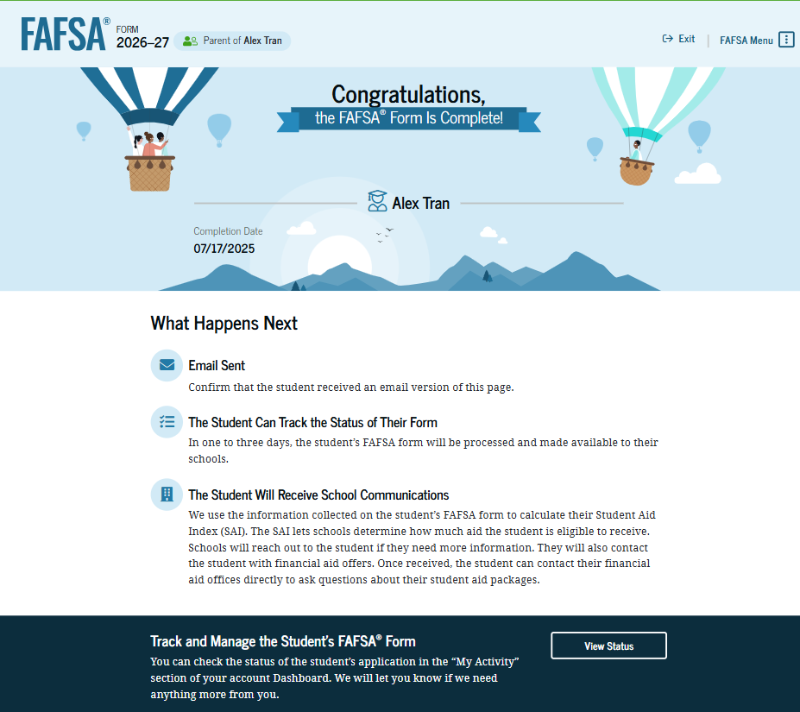
After submitting, the parent contributor will see a confirmation page. Because the FAFSA belongs to the student, it is the student who will receive the confirmation email. Once the FAFSA has processed, one to three days after submission of the form, the student will receive a notice. They will be able to return to the FAFSA to access and review their FAFSA Submission Summary.
Objective #5: Understand the FAFSA Submission Summary
The FAFSA Submission Summary is a summary of information related to the student’s FAFSA. There are four tabs to the summary. There are several key elements to notice below; they include:
- The date the application was received.
- The date the application was processed.
- Which submission is being viewed (corrections to the form generate a new FAFSA Submission Summary).
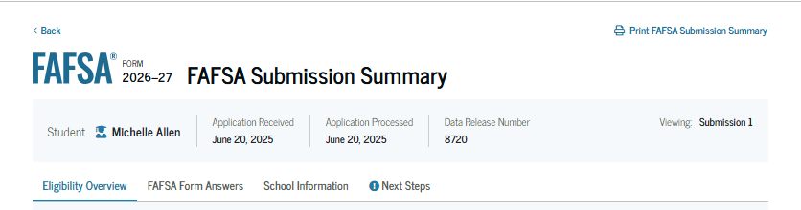
The first tab of the FAFSA Submission Summary is an Eligibility Overview. This page will include an estimate of the student’s Pell Grant if they are eligible. It will also provide the Student Aid Index.
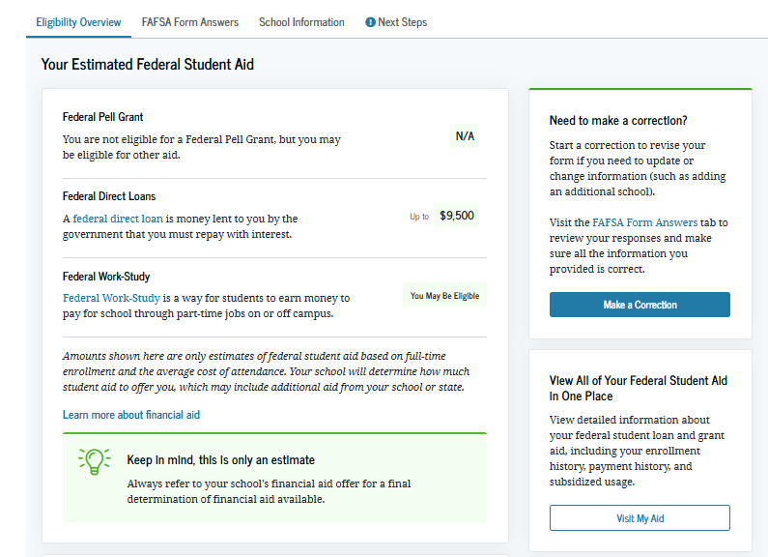
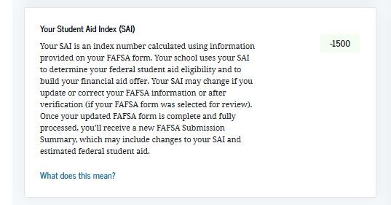
The second tab of the FAFSA Submission Summary is an actual summary of the answers reported on the FAFSA itself.

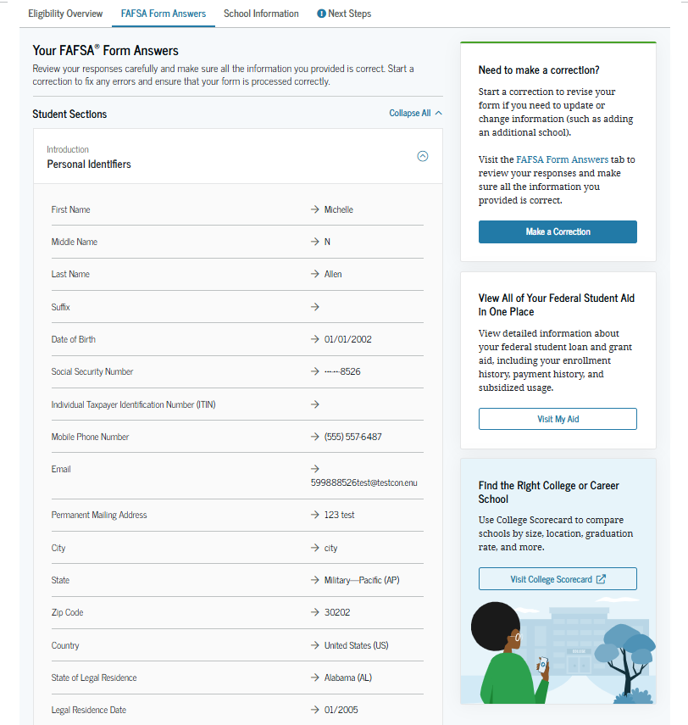

The third tab is school information, where students can view key data elements about their prospective institution(s), including graduation and retention rates; median debt upon completion; average annual cost; and more.
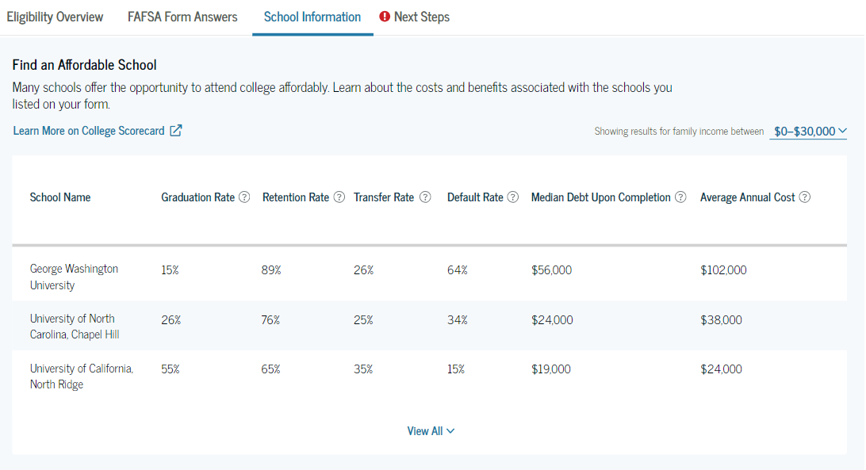
The fourth and final tab outlines the next steps. If the student has required action, the FAFSA Submission Summary should open directly to that tab first.
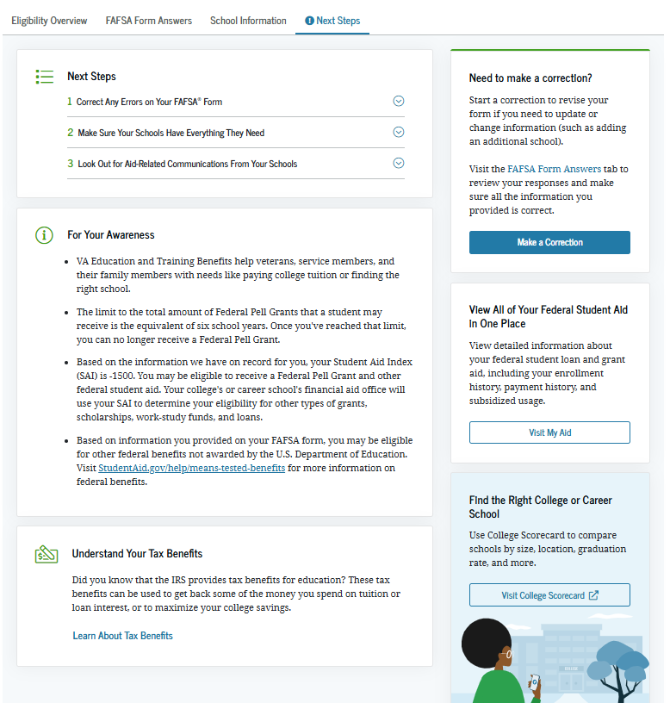
Objective #6: Learn when to consider a special circumstances appeal.
Special Circumstances Appeal
The FAFSA is a form, and many aspects of students’ lives, experiences, and financial circumstances are not accounted for when applying for financial aid. Some circumstances may be considered through a process known as a special circumstances appeal.
Special circumstances appeals are a form of professional judgement review (unusual circumstances, which is the dependency override process, is also a form of professional judgement review). If a student has new or additional financial matters that affect their ability to cover the costs of college, they may follow up directly with their prospective college(s) and request the school consider this information.
Here are some examples of circumstances that may be considered:
- Recent reduction or loss of income
- Change in employment for a member of the house
- Extenuating costs due to ongoing illness, hospitalization, etc.
Please be aware that although it is always advisable to explore the possibility of an appeal, not all circumstances are considered by a college or will yield a change in the student’s aid eligibility. It is the professional judgement of the financial aid administrator at the college. A successful appeal would mean the financial aid administrator makes changes to data in the student’s FAFSA, prompting the form to recalculate a new SAI and, as result, potentially changing the student’s aid eligibility.

Scholarship Foundation Student Advisors can assist you in navigating this process; please contact us by email at info@sfstl.org or phone at (314) 725-7990.

Frequently Asked Questions
If my parents are divorced, whose information do I need to provide?
Report the information of the parent who provided more than 50% of the student’s financial support in the most recent 12 months. Financial support can be determined by considering who covers the greater share of the student’s expenses, including, but not limited to housing, food, utility costs, health insurance, car note, car insurance, school fees, etc. If the student’s parents support the student equally, the student should provide the financial information for the parent who has the greater income. Please note that if the parent whose information is required is remarried, the stepparent’s information is also required. In addition, if the student’s biological parents are divorced, but still share a household (live under one roof together), both parents’ information is required on the FAFSA.
Whose income do I report if I live with a grandparent, aunt, family friend, etc. (anyone other than a biological or adoptive parent)?
Federal Student Aid is clear—only biological or adoptive parent information should be included on the FAFSA. Students who reside with a grandparent, aunt/uncle, or another adult may, depending on circumstances, be considered an independent student, which means no parent/guardian information is required. Otherwise, students may need to pursue a dependency override or begin conversation with their parent(s) to secure required information.
What kind of information is required in a dependency override?
Schools often require the student to submit paperwork to request a dependency override. This includes a school form, as well as supporting documentation. The supporting documentation will vary depending on the student’s specific circumstances. For example, a student who has left the home due to abuse or neglect may be asked to provide copies of police reports, any relevant reports from the Division of Child and Family Services (or similar entities), etc. Letters of support or corroboration from school counselors, social workers, faith leaders, and others familiar with the student’s circumstances are often needed too. Although the burden of proof is on the student, students do not have to go through this alone. The Scholarship Foundation’s Student Advisors are here to listen, support, and help. Please contact us at info@sfstl.org or (314) 725-7990 for assistance.
What if I need or want additional help?
Help exists!
First, help text is available for every question on the FAFSA.
If you’d like to schedule a free one-on-one appointment, or attend a FASFA clinic, please contact the Foundation at info@sfstl.org or call the office at (314) 725-7990. Clinics are in-person, although one-on-one appointments may be in-person or virtual.

2026-27 FAFSA Checklist
Complete the Free Application for Federal Student Aid, or FAFSA, at https://studentaid.gov to apply for federal, state, and institutional financial aid.
Dependent students must include parent(s) information on the FAFSA. To determine dependency status, see the dependency status worksheet.
- Student’s Social Security Number, legal name, and birthdate
Please reference the student’s social security card to ensure information matches.

- Parent Contributor(s) Social Security Number(s)/Individual Taxpayer Identification Number(s) (ITIN), legal name(s), and birthdate(s)
Please reference the parent contributor(s) social security card(s) to ensure information matches.

- Student Federal Student Aid ID
IDs are created at https://studentaid.gov.

- Parent Contributor(s) Federal Student Aid ID
IDs are created at https://studentaid.gov

- 2024 federal income tax forms, including the 1040 and any schedules and forms
Although most federal tax information will be directly transferred from the IRS, some manual entry will be required. Tax filers can use copies in their personal records or request documentation from the IRS at www.irs.gov.

- 2024 W-2s and/or 1099s

- Current (date of FAFSA filing) cash, checking, and savings account balances
Students and their contributor(s) will need to confirm via personal banking records.

- Current (date of FAFSA filing) net worth investment values
Students and their contributor(s) will need to confirm via statements from their financial institutions.

- Current (date of FAFSA filing) net worth of businesses or investment farms, if applicable
Students and their contributor(s) will need to confirm the net worth.
2026-2027 Dependency Checklist

Dependency Status Questions
Answer the following questions to determine your dependency status for the FAFSA.
Were you born before January 1, 2003? | Yes | No
Are you married? | Yes | No
Will you be enrolled in a master’s or doctorate program at the beginning of the 2026-27 school year? | Yes | No
Are you a veteran of the U.S. Armed Forces or currently serving on active duty? | Yes | No
Do you have children who will receive more than half of their financial support from you? | Yes | No
At any time since you turned 13, were both your parents deceased, were you in foster care, or were you a dependent or ward of the court? | Yes | No
Are you or were you an emancipated minor as determined by a court in your state of legal residence? | Yes | No
Are you or were you in legal guardianship as determined by a court in your state of legal residence? | Yes | No
At any time on or after July 1, 2025, were you homeless? | Yes | No

If you answer “no” to every question, you are dependent and must provide parental information on the FAFSA.

If you answer “yes” to any question, you are independent and should not include parental
Federal Student Aid (FSA) ID

Federal Student Aid IDs (FSA ID), or StudentAid.gov accounts, are a username and password, created by the individual student and/or parent. FSA IDs are used to log-in to the Student Aid website, provide consent and approval for the IRS to share tax information, and sign the Free Application for Federal Student Aid (FAFSA). All FAFSA-filers are required to create an FSA ID; if the student is dependent, a parent and, in some cases, two parents are required to create an FSA ID. To determine your dependency status, please visit: https://studentaid.gov/apply-for-aid/fafsa/filling-out/dependency.

- Create an FSA ID at https://studentaid.gov.
- Many FSA IDs are linked to the user’s Social Security Number. Please double check that the name, birthdate, and SSN used on the FSA ID application match exactly what is listed on your Social Security card. They will not work if the Social Security Administration cannot verify the individual’s identity. Identity verification occurs immediately; if your identity cannot be verified, you will be prompted to correct information and will be unable to begin the FAFSA until your identity is verified.
- Parent(s) or spouse contributors to a student’s FAFSA, who do not have a Social Security Number, are still able to create an FSA ID. Individuals will create an ID through the same process but will have their identity verified through a set of knowledge-based identity verification questions.
Please contact us with your questions, concerns, or for help with the process!
- Users are required to link an email address to their FSA ID and may choose to link a cell phone number, which is recommended. Both the email address and a cell phone number must be verified through a two-factor authentication code. The FSA ID is not finalized until the email address, and the cell number, if entered, are verified. Remember:
  - A verified email address can be used interchangeably with the username, offering greater flexibility.
  - A cell phone number can be used across multiple accounts (up to five) for multifactor authentication. If the username and/or password are forgotten, a user may send a secure code to their verified email and/or cell phone number, which allows for easier retrieval and/or reset.
- Federal Student Aid uses a two-step verification process. All FSA ID users are required to set up, and use, two-step verification. Individuals may use their verified email address and/or cell phone numbers for two-step verification; users also may choose to use an authenticator app.
- All FSA ID users will receive an optional backup code. It provides an additional account verification option, although it is a one-time use only. Consider copying the backup code and storing it in a safe and secure place.
- Federal Student Aid does not permit passwords to include any aspects of the user’s legal name, DOB, or SSN.
- Document your information in a safe and secure way; best practice is to store in a password manager. You can also document photos in a locked note or album on a device. If you write it down, be sure to save it in a secure file at home.

Although there are many reasons why students create parent FSA IDs (and vice versa), please only create an FSA ID for yourself. An FSA ID serves as a legally binding signature. When it is necessary, one suggestion is to use the same password for both accounts, to minimize what detail needs to be remembered.

Student:
Email Address:
Cell Phone Number: _____________________________________________________________
Username:
Password:
Backup Code: _______________________________________________________

Parent 1 (If applicable):
Email Address:
Cell Phone Number: _____________________________________________________________
Username:
Password:
Backup Code: _______________________________________________________

Parent 2 (If applicable):
Email Address:
Cell Phone Number: _____________________________________________________________
Username:
Password:
Backup Code: _______________________________________________________

The Scholarship Foundation’s Student Advising Team

Liliana De La Garza Fischer Ricky Hughes
Bilingual Student Advisor Student Advisor
(314) 932-6935 (314) 932-6939
liliana@sfstl.org ricky@sfstl.org

DeVonte’ (DJ) Jackson Dominesha Newton
Student Advisor Lead Student Advisor
(314) 932-6940 (314) 932-6937
dj@sfstl.org dominesha@sfstl.org

Teresa Stock Steinkamp, LMSW
Director of Advising
(314) 932-6932
teresa@sfstl.org

Learn more and meet the advisors:
https://sfstl.org/advice-assistance/advisor-bios/

The Scholarship Foundation of St. Louis
6825 Clayton Ave, Suite 100, St. Louis, MO 63139
main: 314.725.7990
fax: 314.725.5231
sfstl.org

Teresa Stock Steinkamp, LMSW
Revised May 2026

Eligible students include US citizens, as well as eligible non-citizens, which includes those who are legal permanent residents and have a green card. Students who are unable to file a FAFSA are encouraged to contact The Scholarship Foundation for assistance in exploring other financial aid options, including funding available through The Scholarship Foundation’s grant and interest-free loan programs.
The term “unusual circumstances” is Federal Student Aid’s language. The Scholarship Foundation considers this language problematic and will use other language whenever possible to describe or discuss provisionally independent students, their circumstances, and the dependency override process.
For more information about the Direct Loans, both subsidized and unsubsidized, please visit: https://studentaid.gov/understand-aid/types/loans/subsidized-unsubsidized.
If the parent(s) did not file a Schedule A, B, D, E, F, or H and did not file a Schedule C, or they file a Schedule C with net business income of not more than a $10,000 loss or gain.
The reference to 2024 or 2025 is specific to the 2026-27 FAFSA.

